**MedTrack: AWS Cloud-Enabled Healthcare Management System**

**Project Description:**

In today’s fast-evolving healthcare landscape, efficient communication and coordination between doctors and patients are crucial. MedTrack is a cloud-based healthcare management system that streamlines patient doctor interactions by providing a centralized platform for booking appointments, managing medical histories, and enabling diagnosis submissions. To address these challenges, the project utilizes Flask for backend development, AWS EC2 for hosting, and DynamoDB for managing data. MedTrack allows patients to register, log in, book appointments, and submit diagnosis reports online. The system ensures real-time notifications, enhancing communication between doctors and patients regarding appointments and medical submissions. Additionally, AWS Identity and Access Management (IAM) is employed to ensure secure access control to AWS resources, allowing only authorized users to access sensitive data. This cloud-based solution improves accessibility and efficiency in healthcare services for all users.

**Scenario 1: Efficient Appointment Booking System for Patients**

In the MedTrack system, AWS EC2 provides a reliable infrastructure to manage multiple patients accessing the platform simultaneously. For example, a patient can log in, navigate to the appointment booking page, and easily submit a request for an appointment. Flask handles backend operations, efficiently retrieving and processing user data in real-time. The cloud-based architecture allows the platform to handle a high volume of appointment requests during peak periods, ensuring smooth operation without delays.

**Scenario 2: Secure User Management with IAM**

MedTrack utilizes AWS IAM to manage user permissions and ensure secure access to the system. For instance, when a new patient registers, an IAM user is created with specific roles and permissions to access only the features relevant to them. Doctors have their own IAM configurations, allowing them access to patient records and appointment details while maintaining strict security protocols. This setup ensures that sensitive data is accessible only to authorized users.

**Scenario 3: Easy Access to Medical History and Resources**

The MedTrack system provides doctors and patients with easy access to medical histories and relevant resources. For example, a doctor logs in to view a patient's medical history and upcoming appointments. They can quickly access, and update records as needed. Flask manages real-time data fetching from DynamoDB, while EC2 hosting ensures the platform performs seamlessly even when multiple users access it simultaneously, offering a smooth and uninterrupted user experience.

AWS ARCHITECTURE

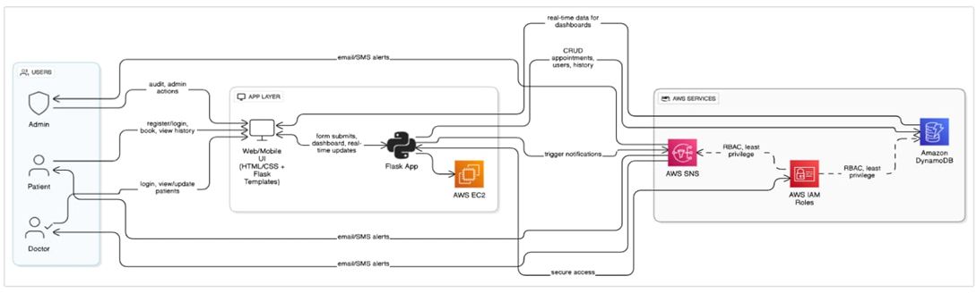

Entity Relationship (ER)Diagram:

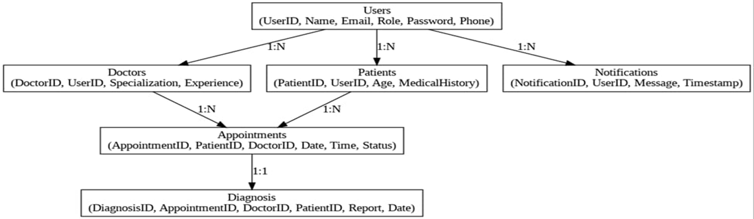

**Pre-requisites:**

AWS Account Setup:https://docs.aws.amazon.com/accounts/latest/reference/getting-started.html

AWS IAM (Identity and Access Management):

https://docs.aws.amazon.com/IAM/latest/UserGuide/introduction.html

AWS EC2 (Elastic Compute Cloud):https://docs.aws.amazon.com/AWSEC2/latest/UserGuide/concepts.html

AWS DynamoDB:https://docs.aws.amazon.com/amazondynamodb/Introduction.html

Amazon SNS: https://docs.aws.amazon.com/sns/latest/dg/welcome.html

Git Documentation:

<https://git-scm.com/doc> VS Code Installation: (download the VS Code using the below link or you can get that in Microsoft store) https://code.visualstudio.com/download

**Project WorkFlow:**

**Milestone 1. Web Application Development and Setup:**

* Develop the Backend Using Flask.
* Integrate AWS Services Using boto3.

**Milestone 2. AWS Account Setup and Login:**

* Set up an AWS account if not already done.
* Login to AWS Management Console.

**Milestone 3. DynamoDB Database Creation and Setup**

* Create a DynamoDB Table.
* Configure Attributes for User Data and Book Requests.

**Milestone 4. SNS Notification Setup**

* Create SNS topics for book request notifications.
* Subscribe users and library staff to SNS email notifications.

**Milestone 5. IAM Role Setup**

* Create IAM Role
* Attach Policies

**Milestone 6. EC2 Instance Setup**

* Launch an EC2 instance to host the Flask application.
* Configure security groups for HTTP, and SSH access.

**Milestone 7. Deployment using EC2**

* Upload Flask Files
* Run the Flask App

**Milestone 8. Testing and Deployment**

* Conduct functional testing to verify user registration, login, book requests, and notifications.

# Milestone 1: AWS Account Setup and Login

* **Activity 1.1: Set up an AWS account if not already done.** 
  1. Sign up for an AWS account and configure billing settings.
     + .

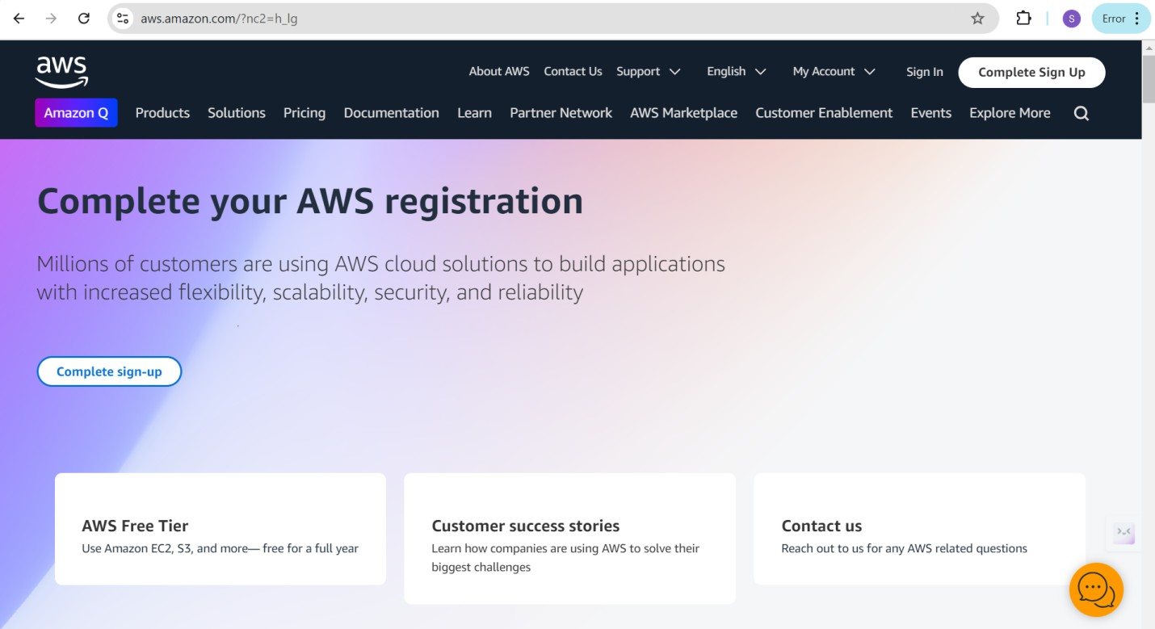

### Activity 1.2: Log in to the AWS Management Console

* + - After setting up your account, log in to the [AWS Management Console](https://aws.amazon.com/console/).

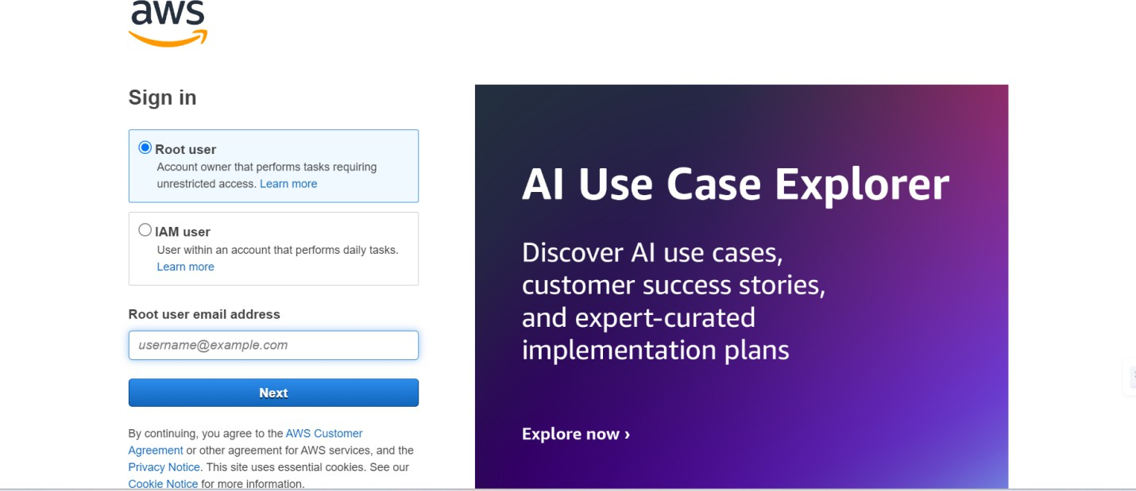

# Milestone 2: DynamoDB Database Creation and Setup

### Activity 2.1:Navigate to the DynamoDB

* + - In the AWS Console, navigate to DynamoDB and click on create tables.
    - 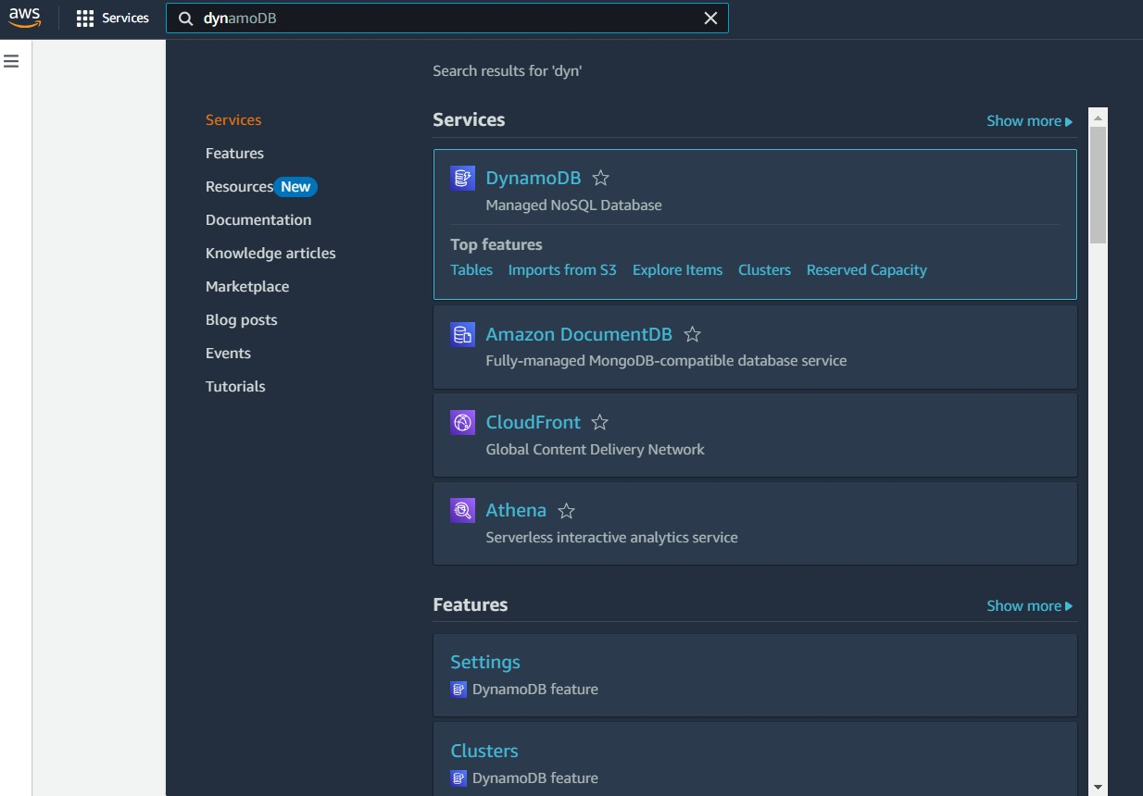

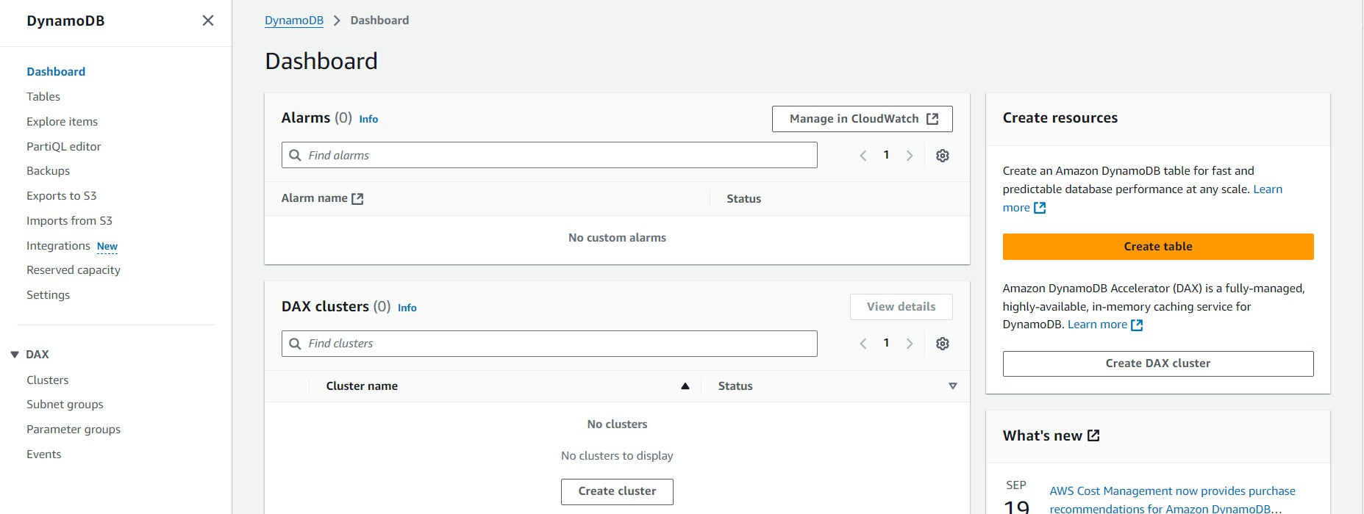

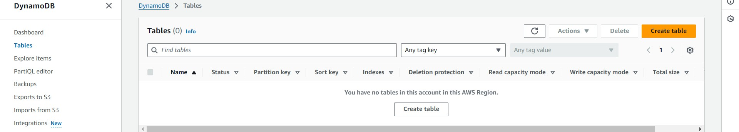

### Activity 2.2:Create a DynamoDB table for storing registration details and book requests.

* + - Create Users table with partition key “Email” with type String and click on create tables.

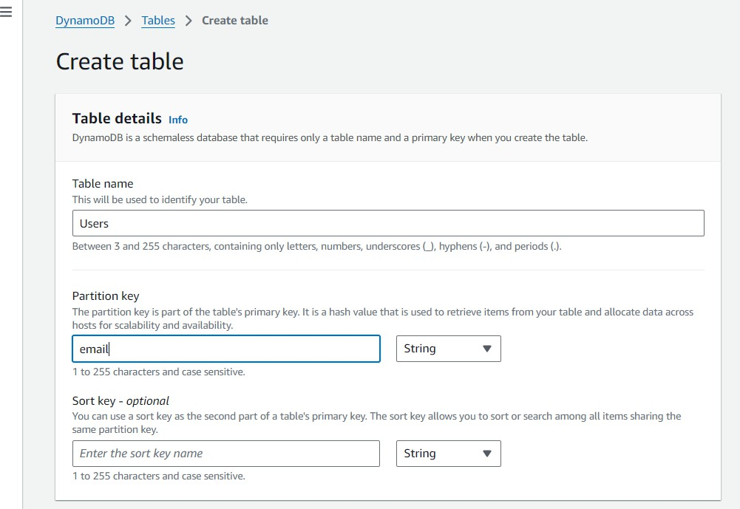

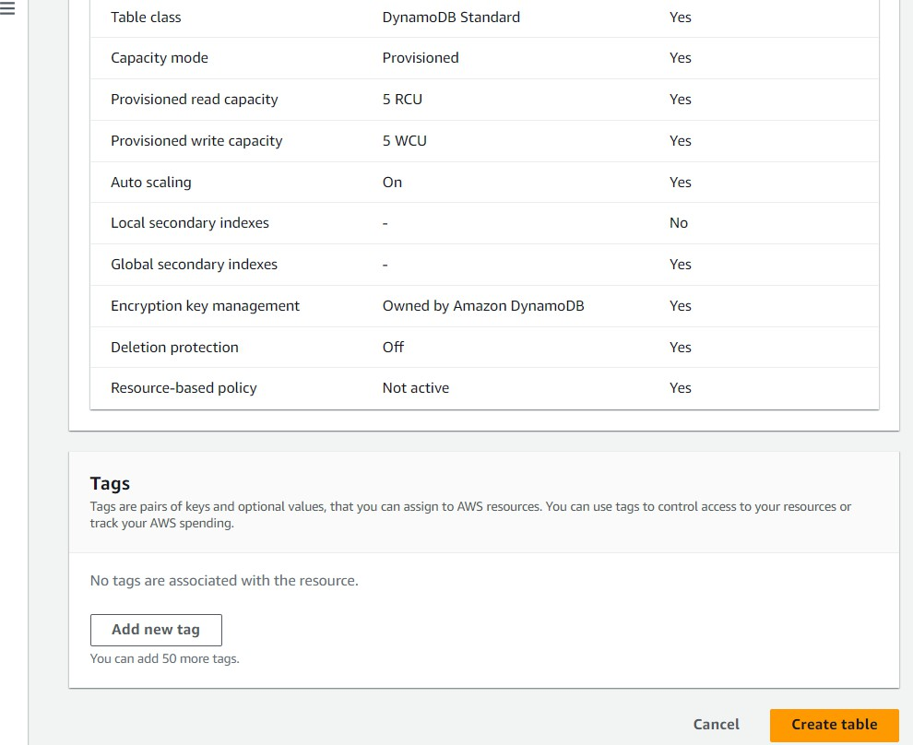

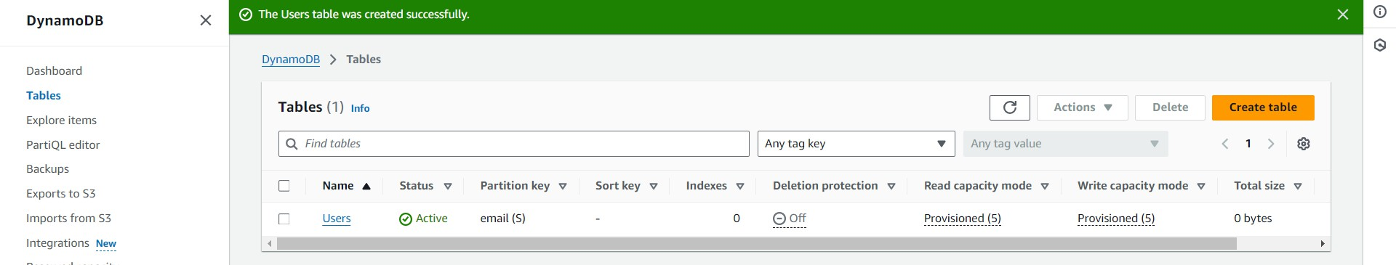

* + - Follow the same steps to create a requests table with Email as the primary key for book requests data.

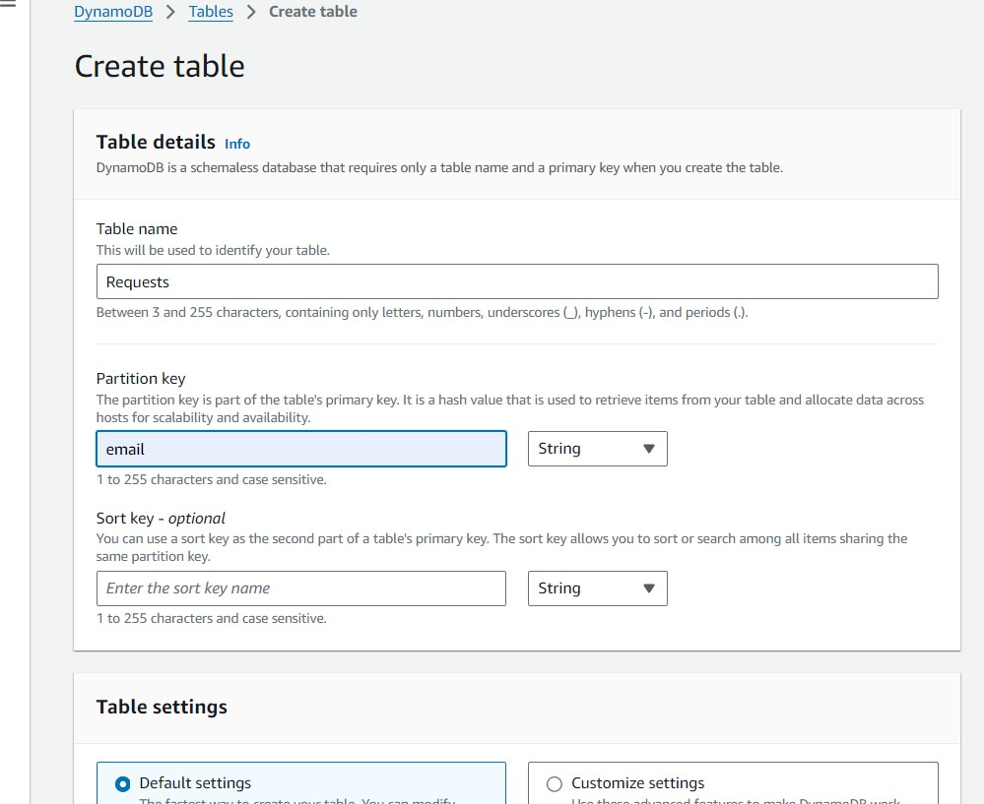

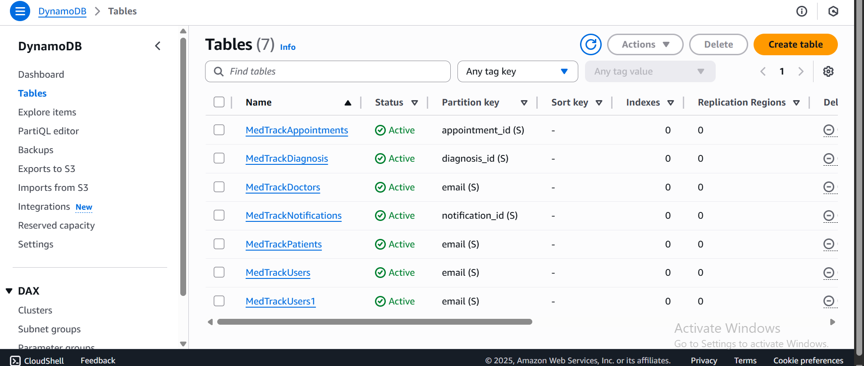

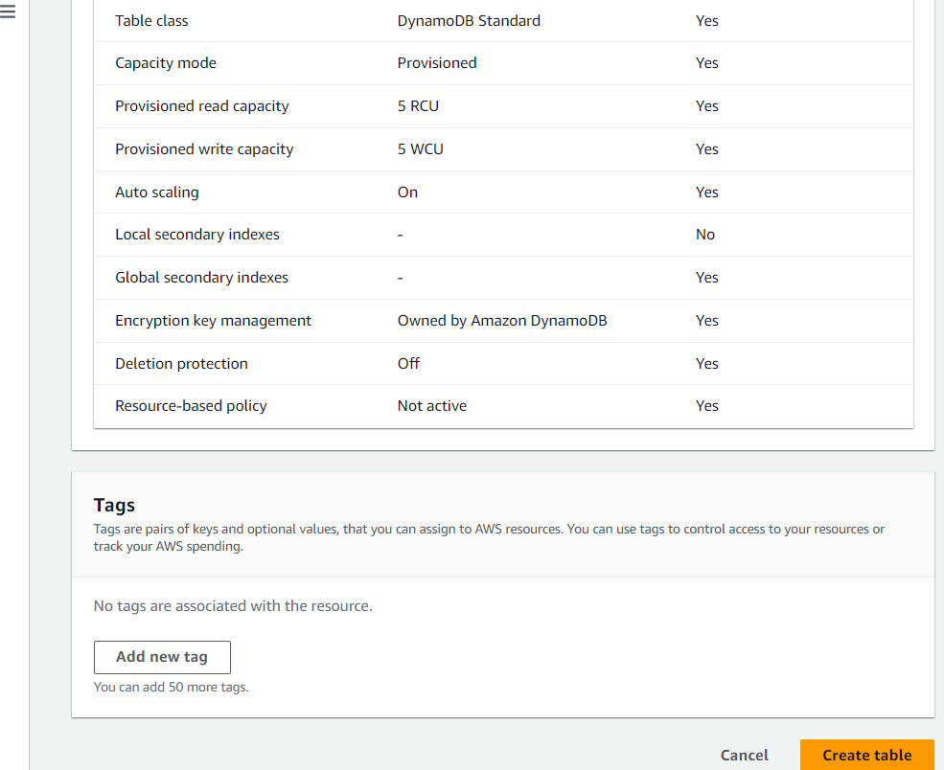

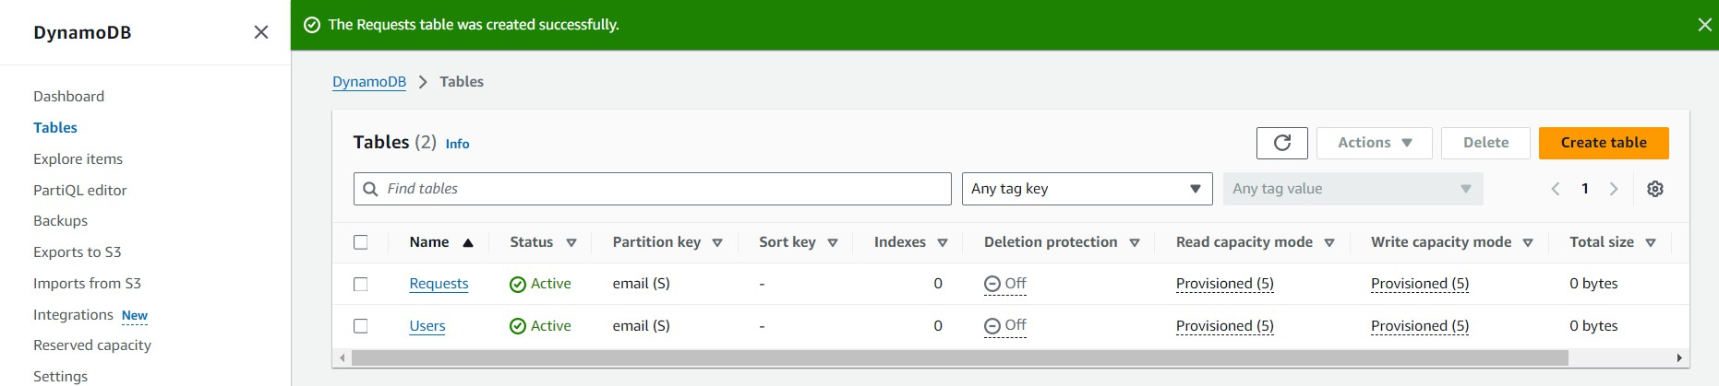

## Milestone 3: SNS Notification Setup

### Activity 3.1: Create SNS topics for sending email notifications to users and library staff.

* + In the AWS Console, search for SNS and navigate to the SNS Dashboard.

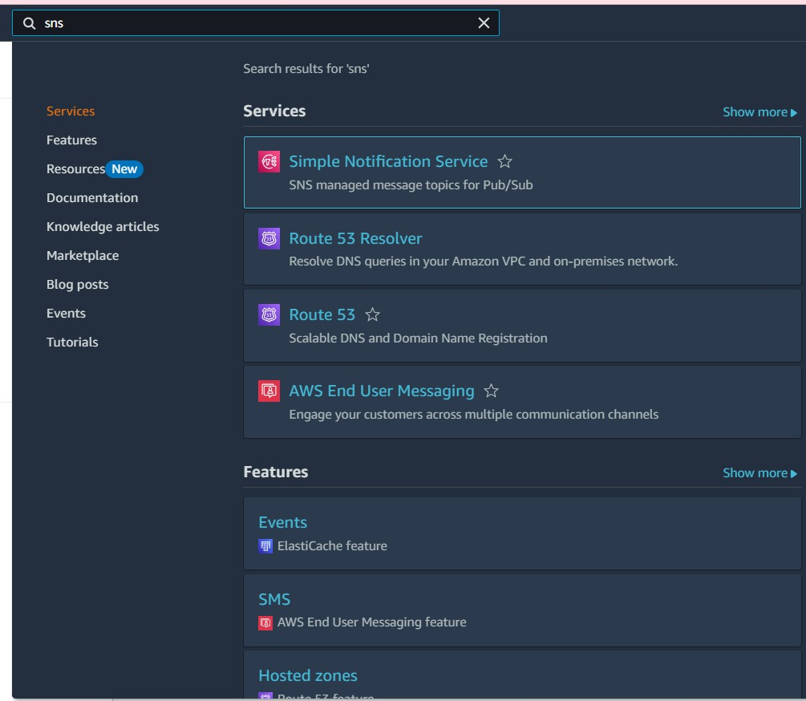

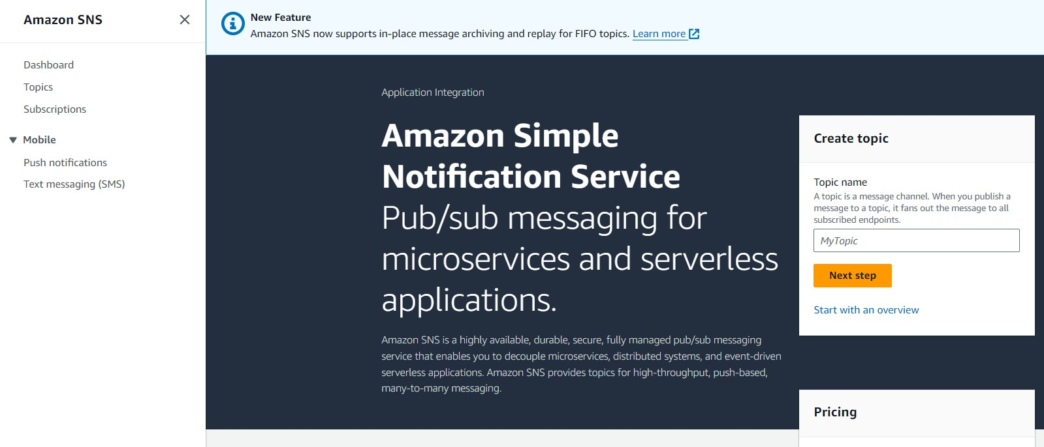

* + Click on **Create Topic** and choose a name for the topic.

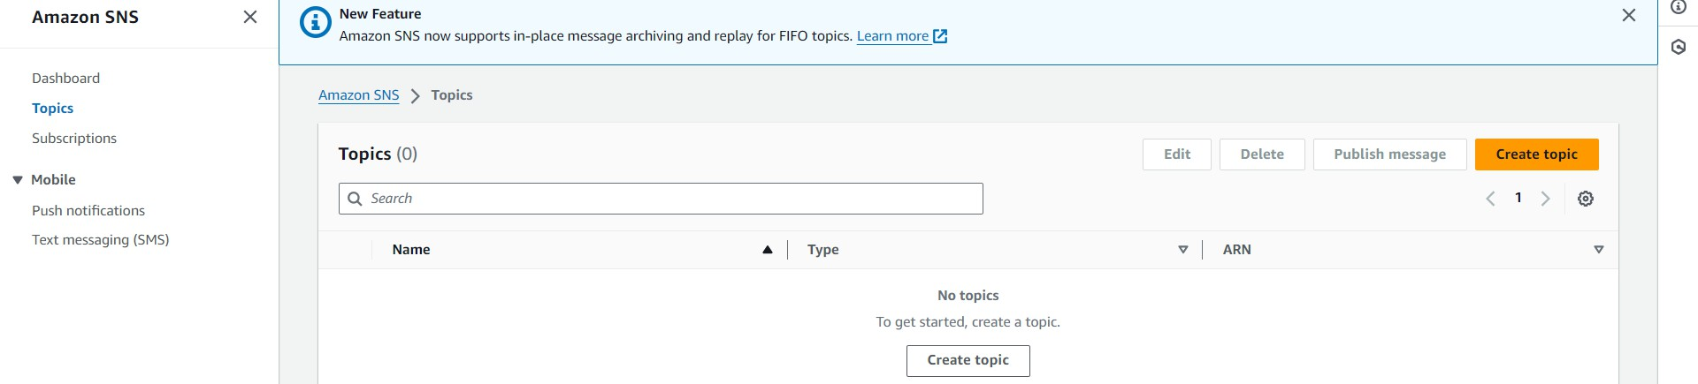

* + Choose Standard type for general notification use cases and Click on Create Topic.

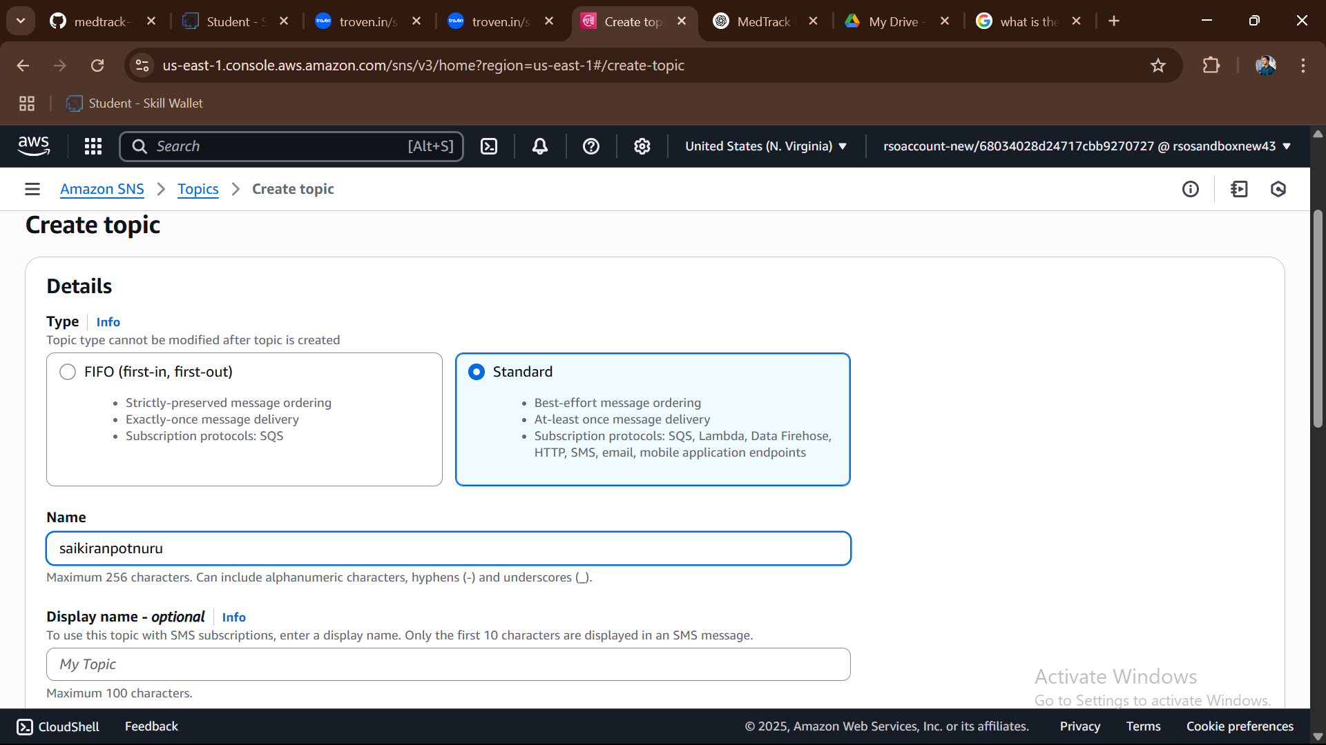

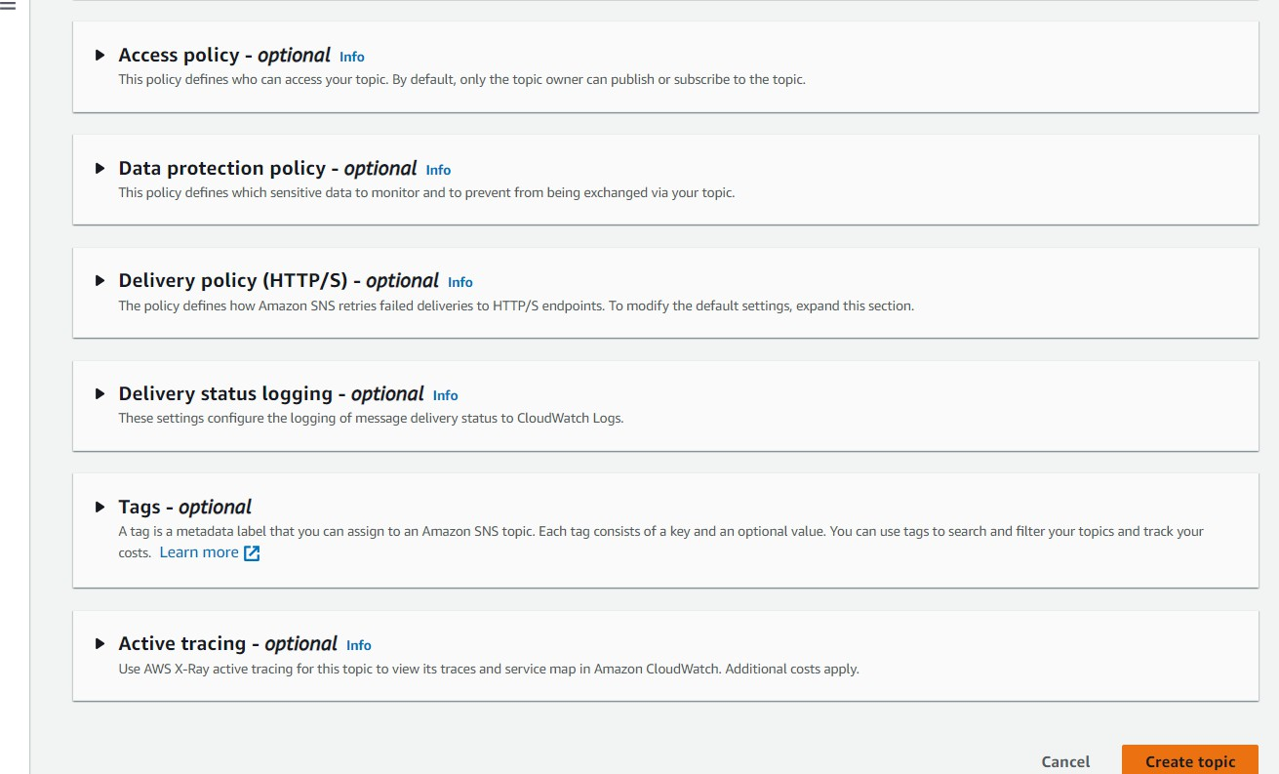

* + Configure the SNS topic and note down the **Topic ARN**.

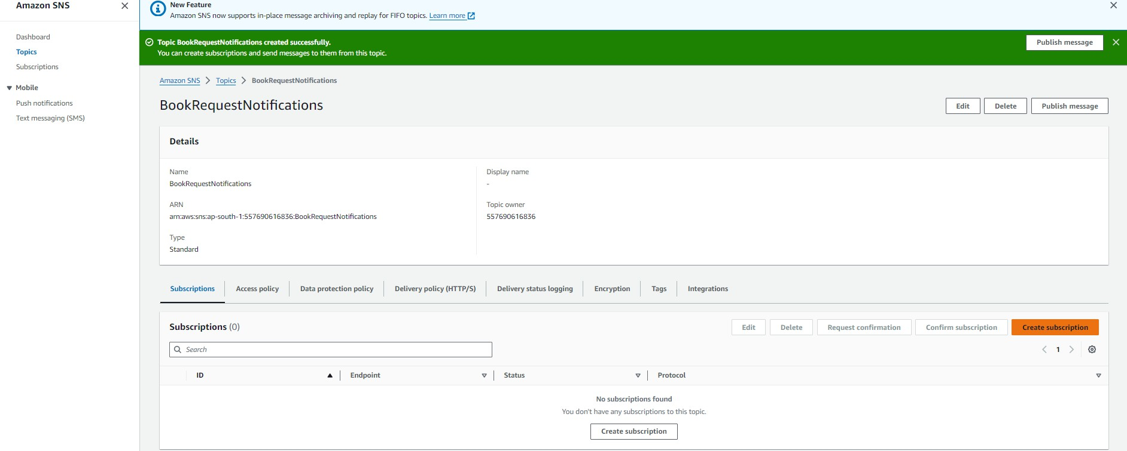

### Activity 3.2: Subscribe users and staff to relevant SNS topics to receive real-time notifications when a book request is made.

* + Subscribe users (or admin staff) to this topic via Email. When a book request is made, notifications will be sent to the subscribed emails**.**

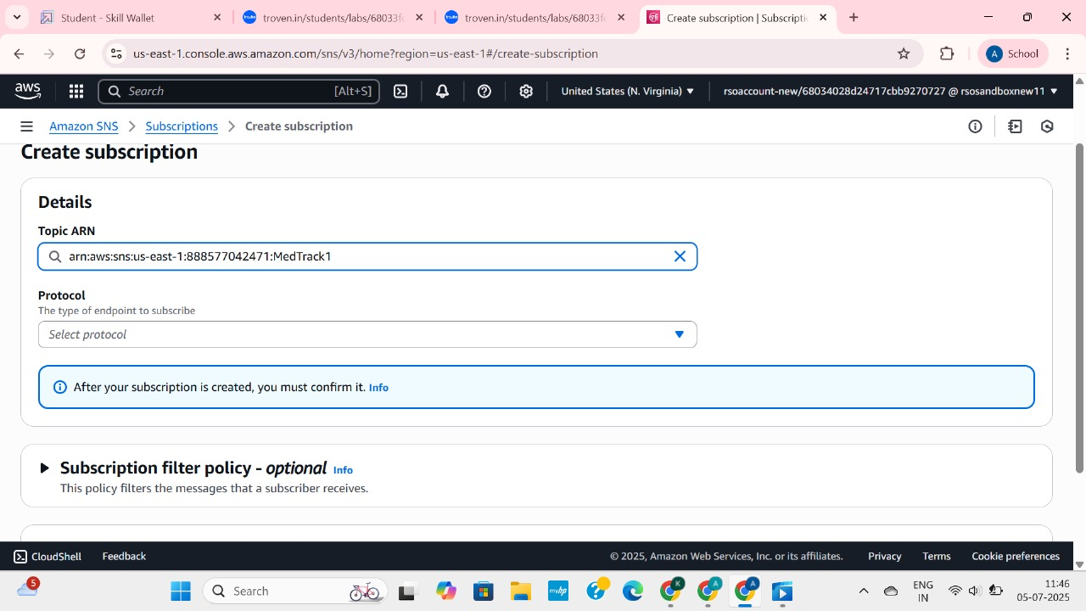

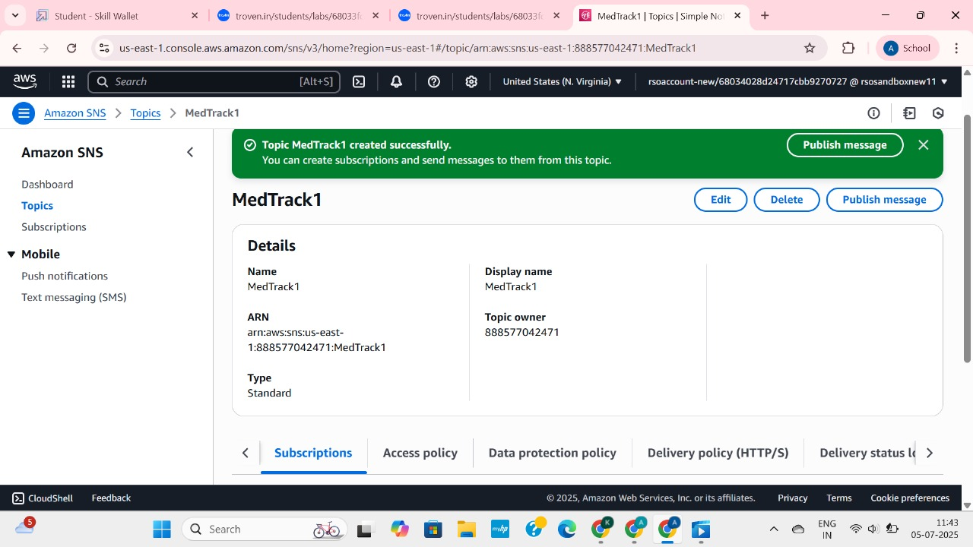

* + After subscription request for the mail confirmation
* 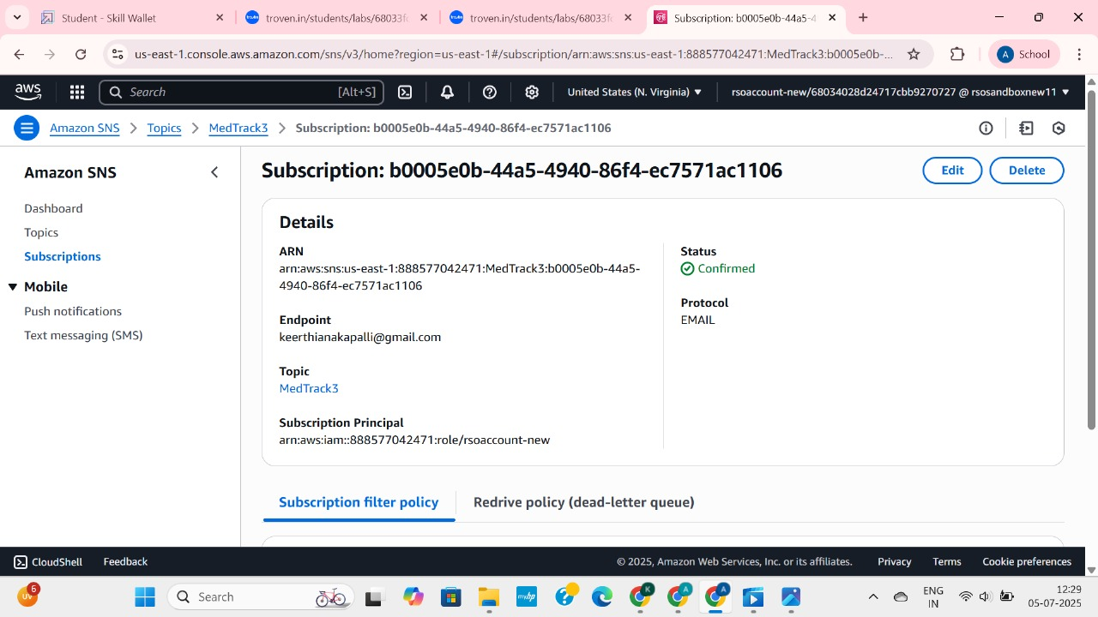
  + Navigate to the subscribed Email account and Click on the confirm subscription in the AWS Notification- Subscription Confirmation mail.

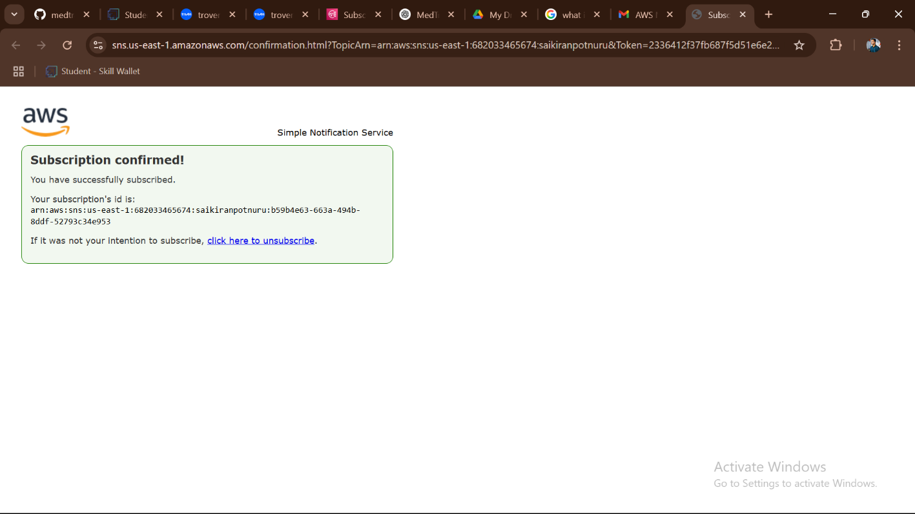

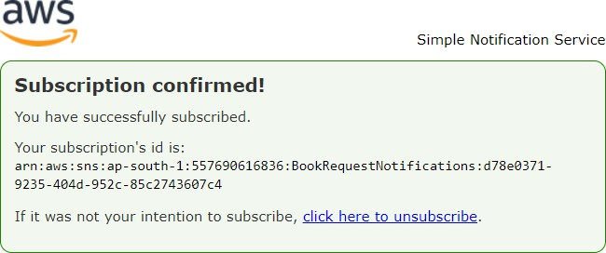

* + Successfully done with the SNS mail subscription and setup, now store the ARN link.

# Milestone 4:Backend Development and Application Setup

### Activity 4.1: Develop the backend using Flask

* + File Explorer Structure
* 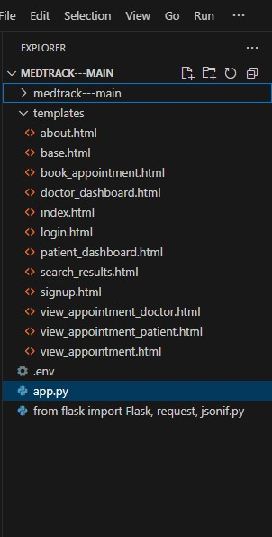

**Description:** set up the INSTANT LIBRARY project with an app.py file, a static/ folder for assets, and a templates/ directory containing all required HTML pages like home, login, register, subject-specific pages (e.g., computer_science.html, data_science.html), and utility pages (e.g., request-form.html, statistics.html).

## Description of the code :

### Flask App Initialization

### C:\Users\Anjali\OneDrive\Pictures\Screenshots\2025-07-08 (3).png

**Description:** import essential libraries including Flask utilities for routing, Boto3 for DynamoDB operations, SMTP and email modules for sending mails, and Bcrypt for password hashing and verification



**Description:** initialize the Flask application instance using Flask( name ) to start building the web app.

### Dynamodb Setup:

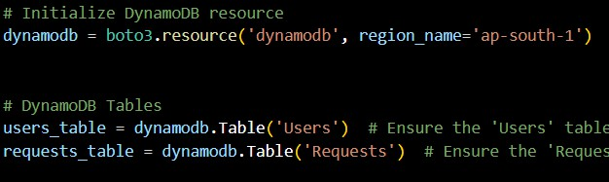

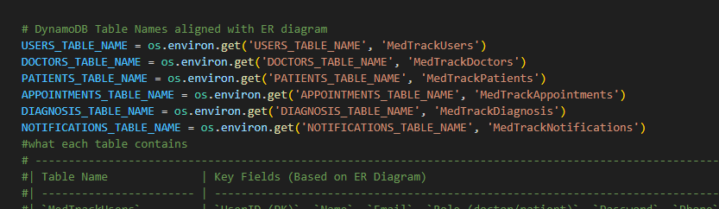

**Description:** initialize the DynamoDB resource for the ap-south-1 region and set up access to the Users and Requests tables for storing user details and book requests.

### SNS Connection

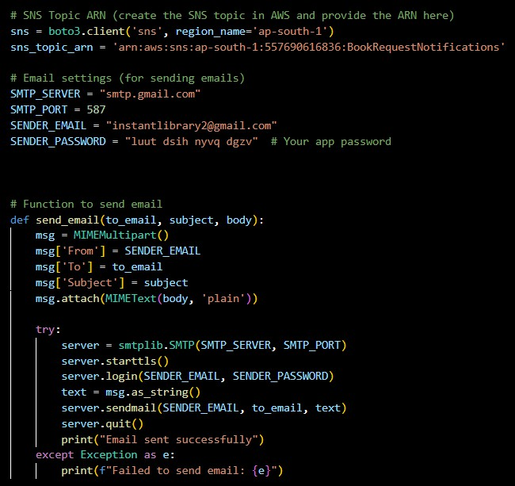

**Description:** Configure **SNS** to send notifications when a book request is submitted. Paste your stored ARN link in the sns_topic_arn space, along with the region_name where the SNS topic is created. Also, specify the chosen email service in SMTP_SERVER (e.g., Gmail, Yahoo, etc.) and enter the subscribed email in the SENDER_EMAIL section. Create an ‘App password’ for the email ID and store it in the SENDER_PASSWORD section.

## Routes for Web Pages

### Home Route:

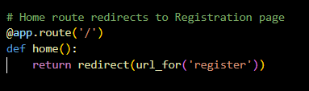

**Description:** define the home route / to automatically redirect users to the register page when they access the base URL.

### Signup Route:

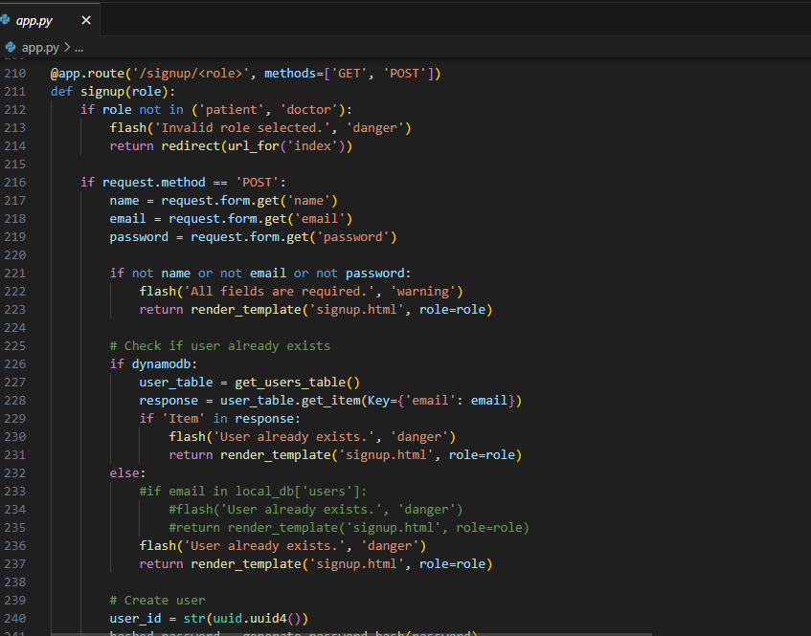

**Description:** define /register route to validate registration form fields, hash the user password using Bcrypt, store the new user in DynamoDB with a login count, and send an SNS notification on successful registration

### Login Route (GET/POST):

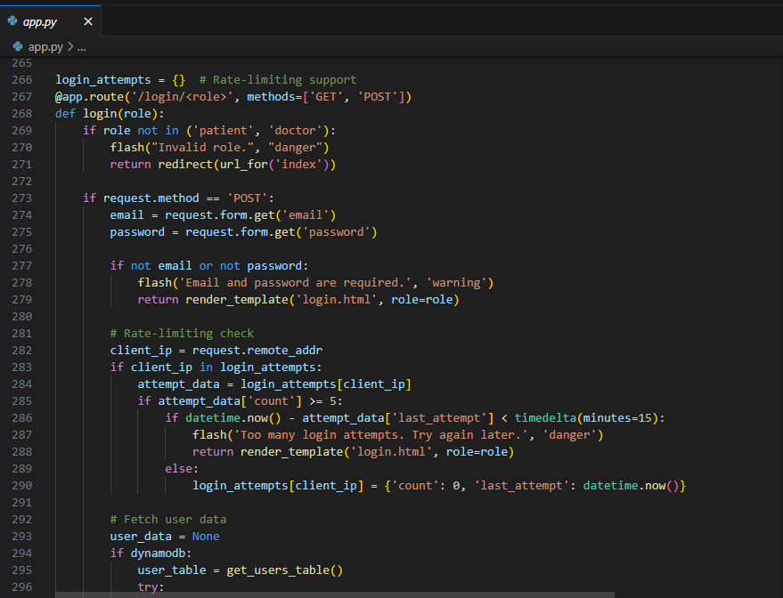

**Logout Route**:

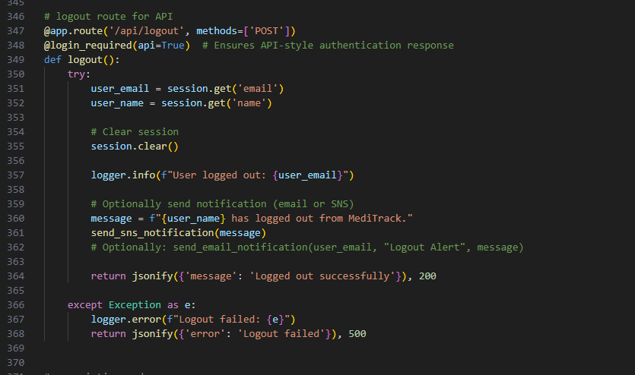

**Description:** define /logout route to render the exit.html page when the user chooses to leave or close the application.

**Deployment Code:**



**Description:** start the Flask server to listen on all network interfaces (0.0.0.0) at port 80

with debug mode enabled for development and testing.

# Milestone 5: IAM Role Setup

### Activity 5.1:Create IAM Role.

* + In the AWS Console, go to IAM and create a new IAM Role for EC2 to interact with DynamoDB and SNS.

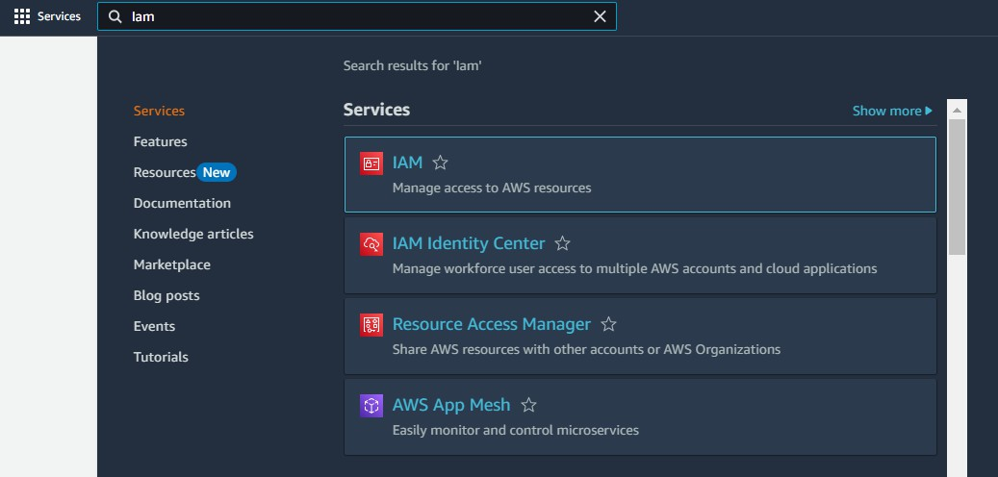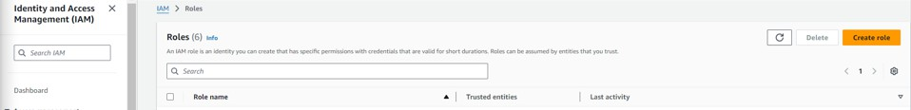

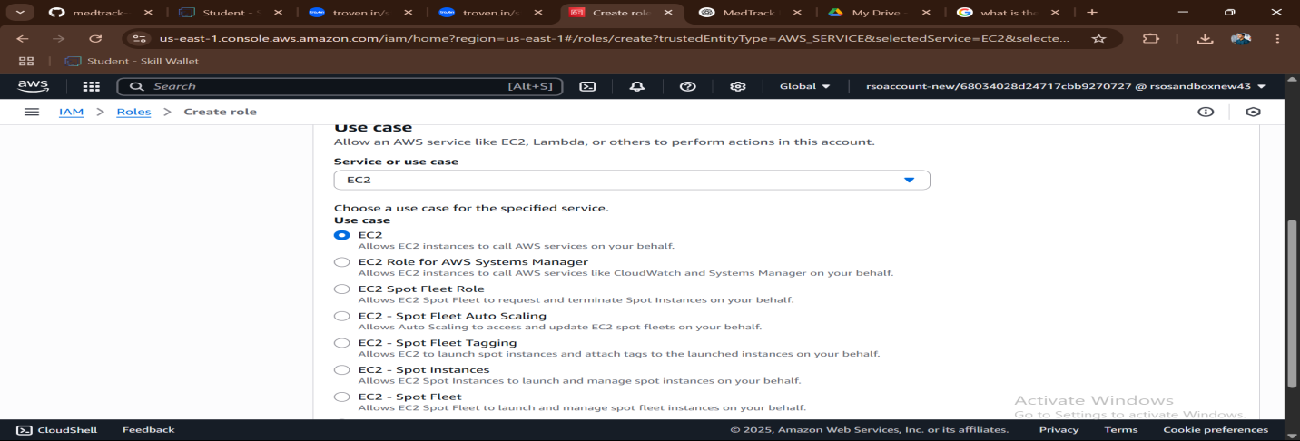

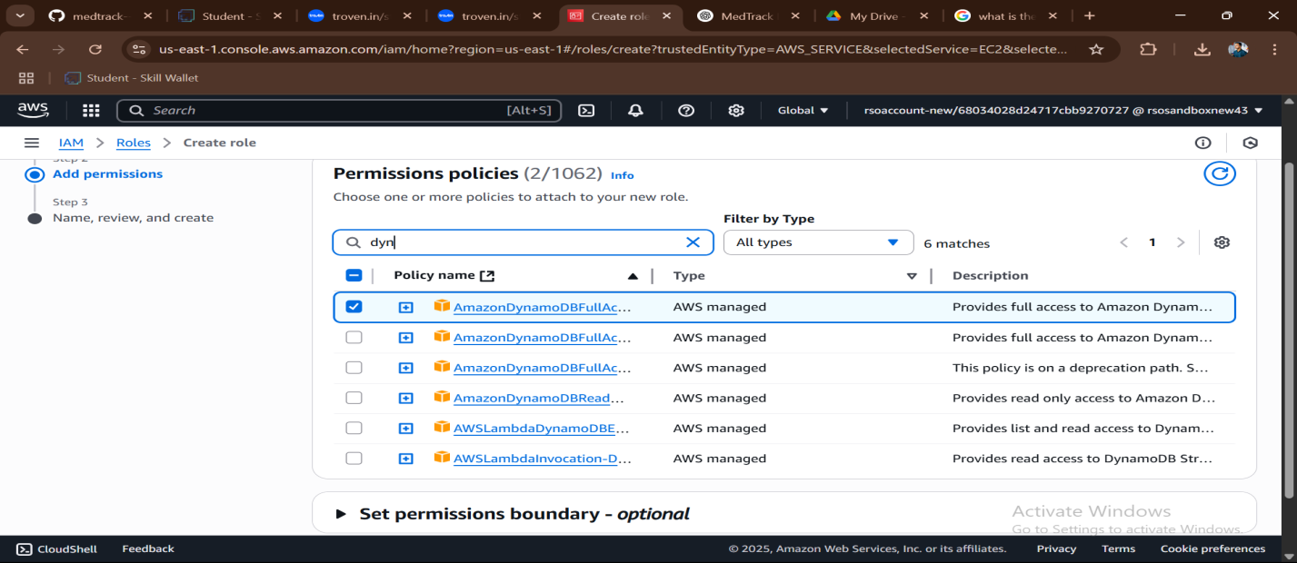

### Activity 5.2: Attach Policies.

Attach the following policies to the role:

* AmazonDynamoDBFullAccess: Allows EC2 to perform read/write operations on DynamoDB.
* AmazonSNSFullAccess: Grants EC2 the ability to send notifications via SNS.

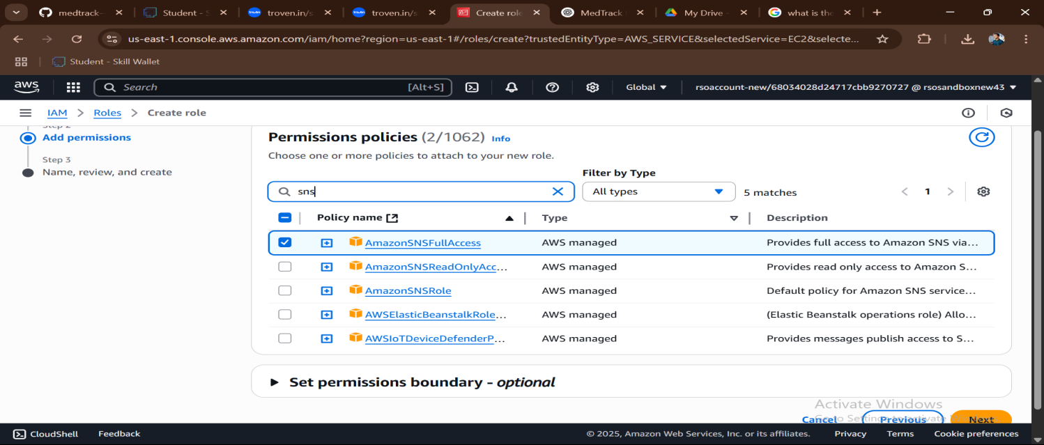

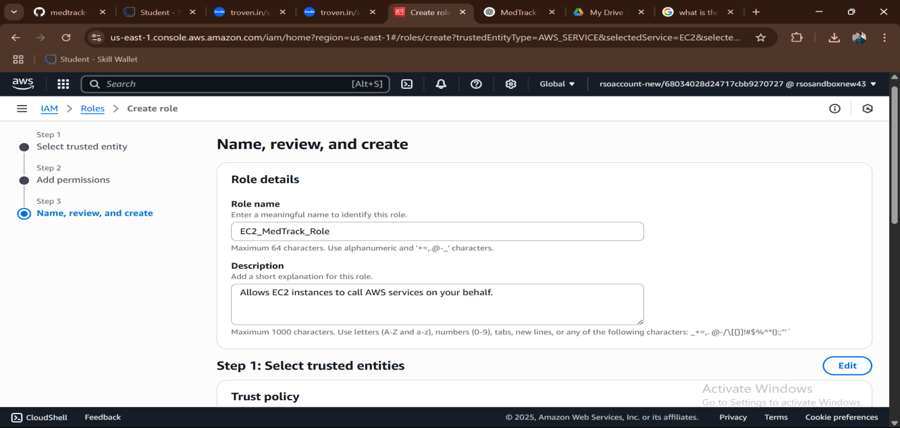

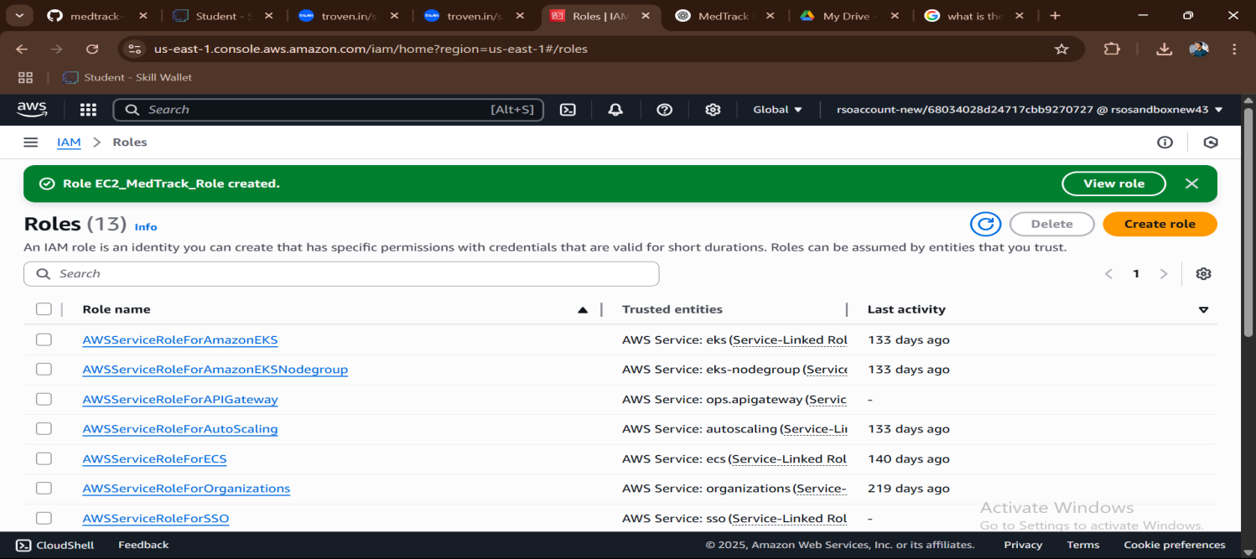

# Milestone 6: EC2 Instance Setup

* **Note: Load your Flask app and Html files into GitHub repository.**

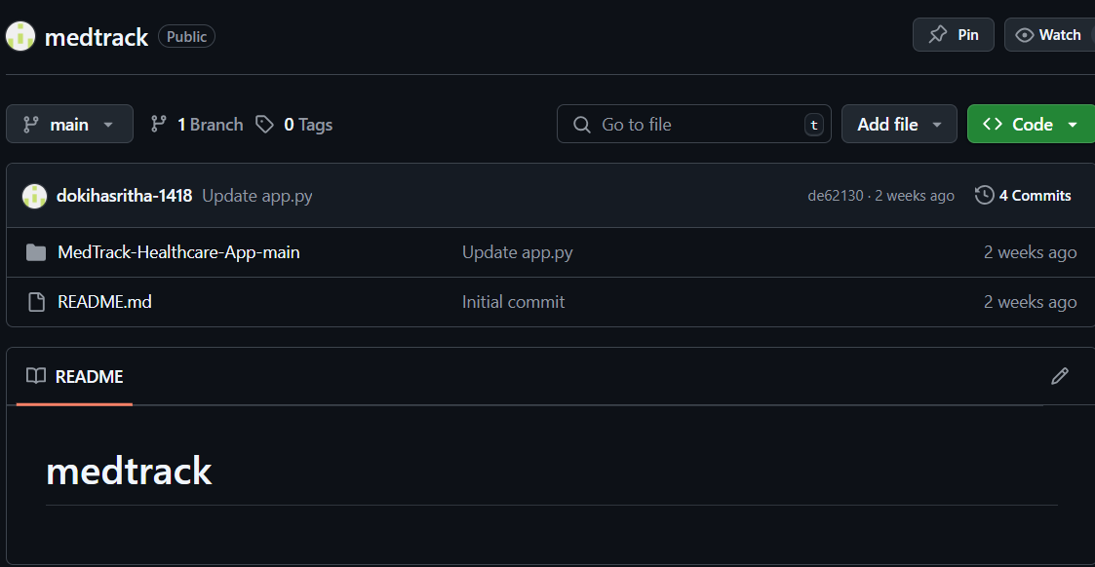

### Activity 6.1: Launch an EC2 instance to host the Flask application.

* + **Launch EC2 Instance**
    - In the AWS Console, navigate to EC2 and launch a new instance.

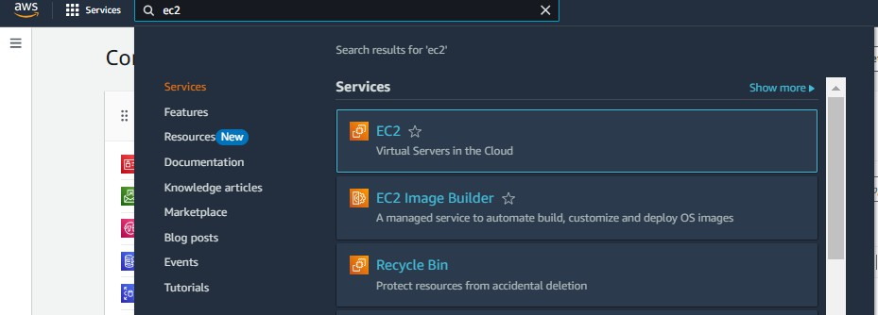

* Click on Launch instance to launch EC2 instance

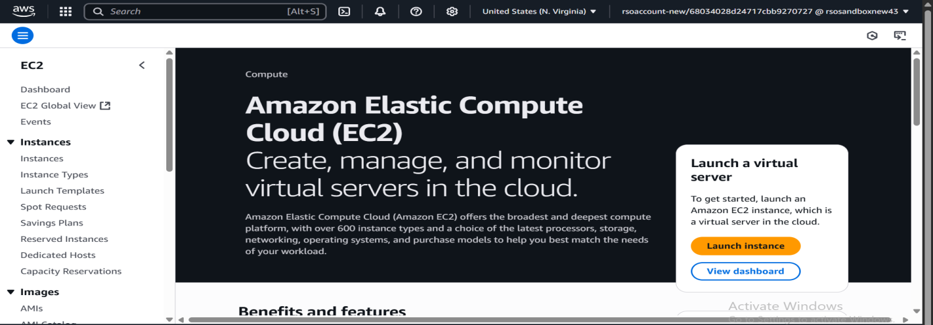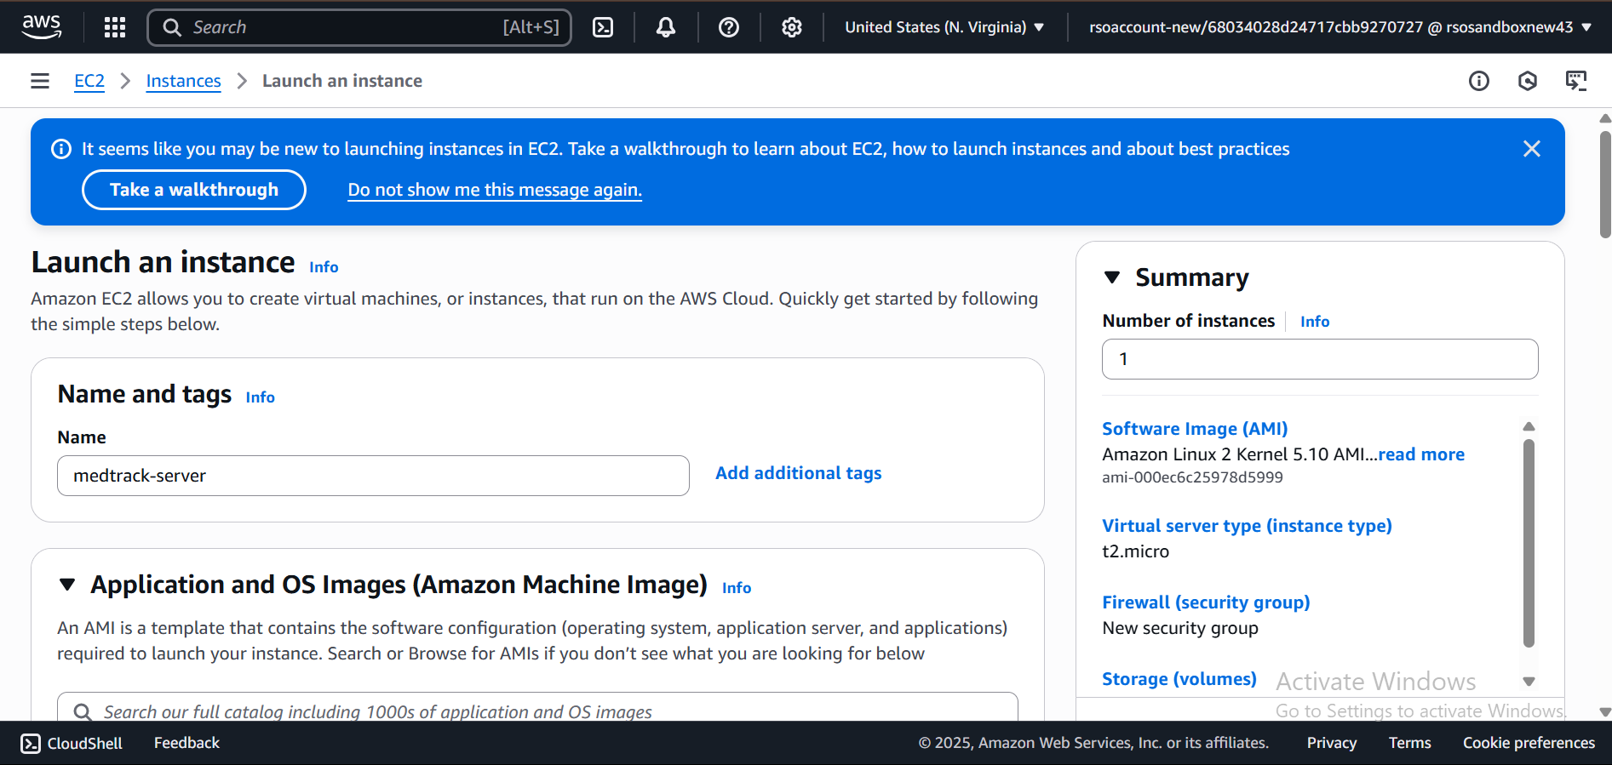

* + Choose Amazon Linux 2 or Ubuntu as the AMI and t2.micro as the instance type (free-tier eligible).

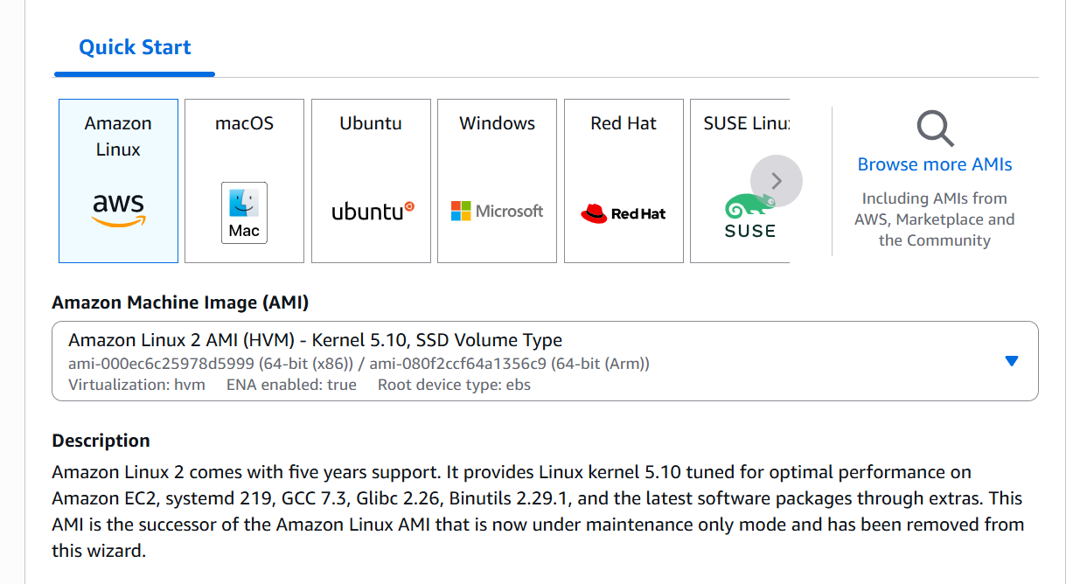

* Create and download the key pair for Server access.

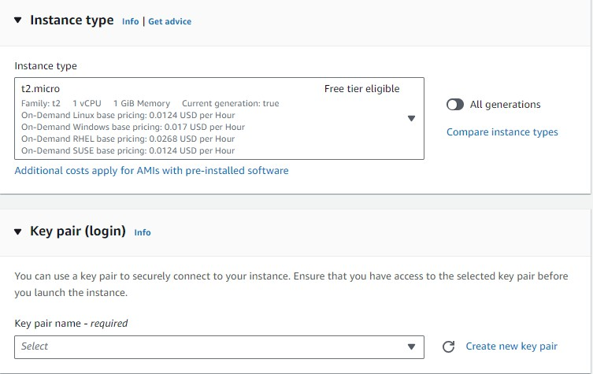

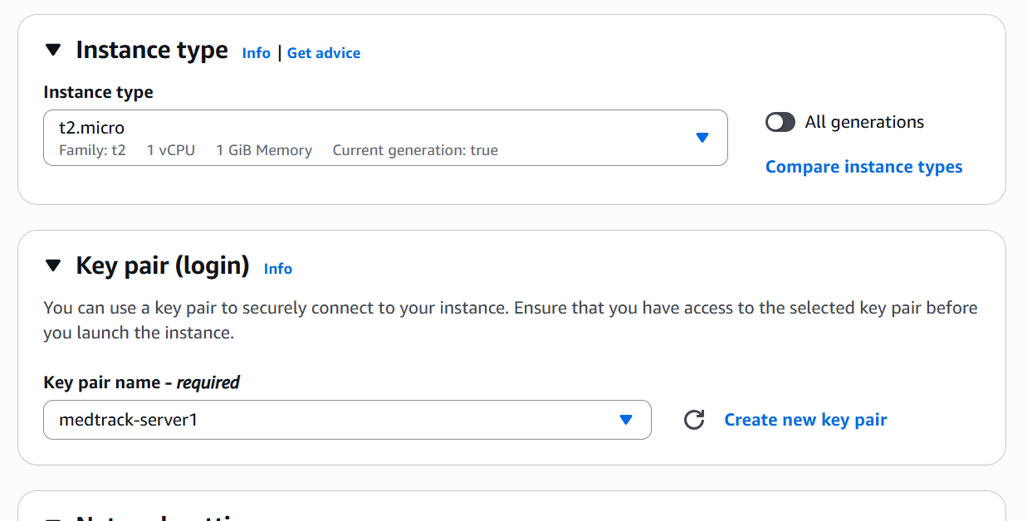

### Activity 6.2:Configure security groups for HTTP, and SSH access.

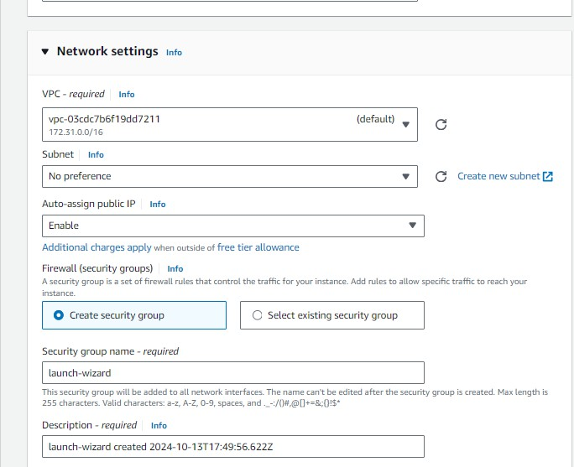

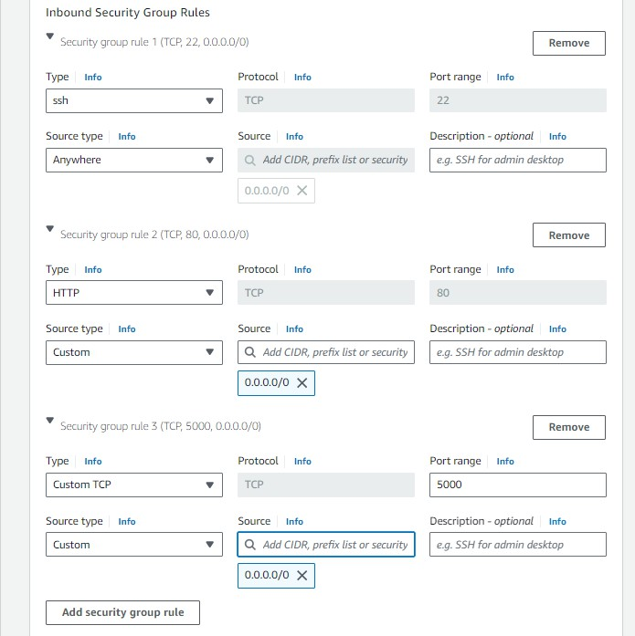

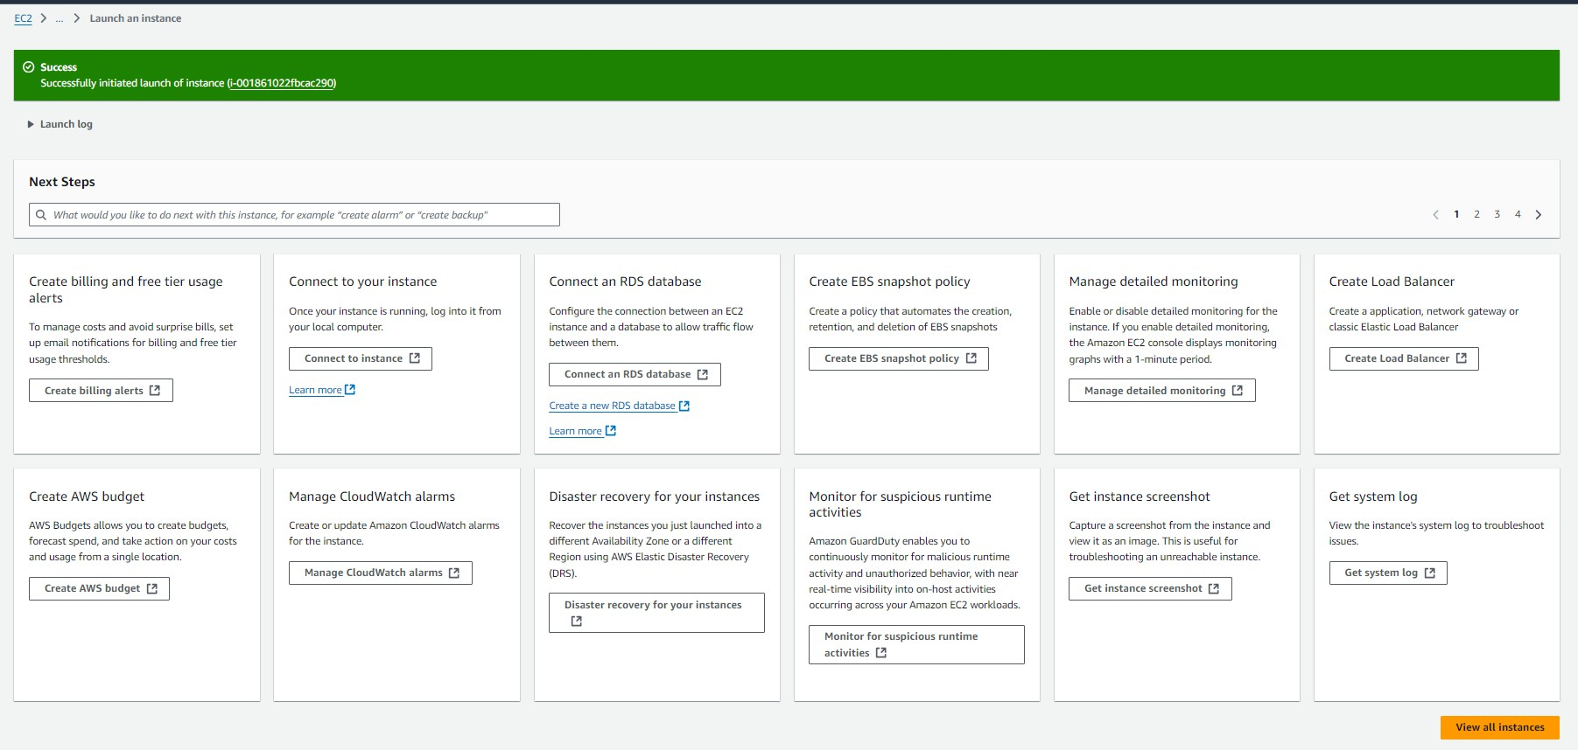

* To connect to EC2 using **EC2 Instance Connect**, start by ensuring that an **IAM role** is attached to your EC2 instance. You can do this by selecting your instance, clicking on **Actions**, then navigating to **Security** and selecting **Modify IAM Role** to attach the appropriate role. After the IAM role is connected, navigate to the **EC2** section in the **AWS Management Console**. Select the **EC2 instance** you wish to connect to. At the top of the **EC2 Dashboard**, click the **Connect** button. From the connection methods presented, choose **EC2 Instance Connect**. Finally, click **Connect** again, and a new browser-based terminal will open, allowing you to access your EC2 instance directly from your browser.

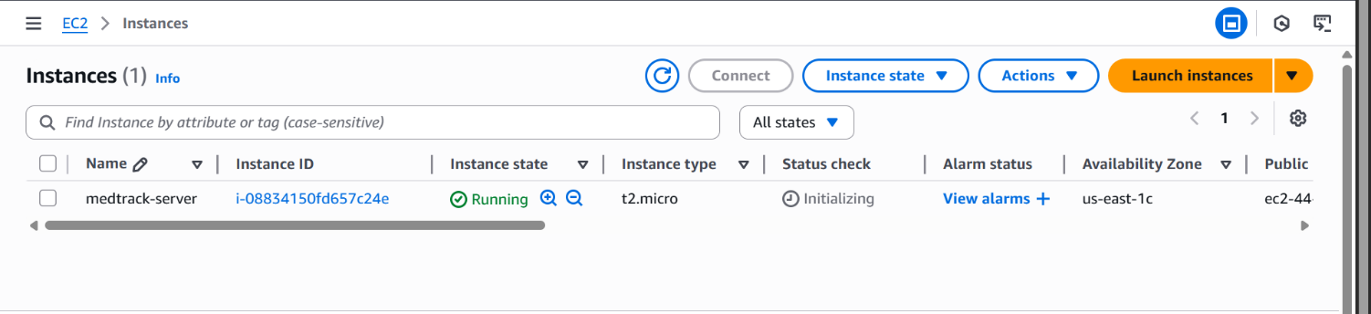

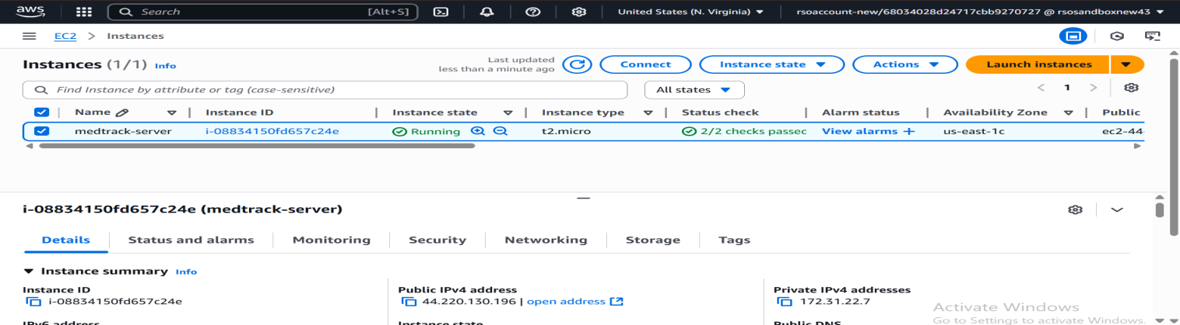

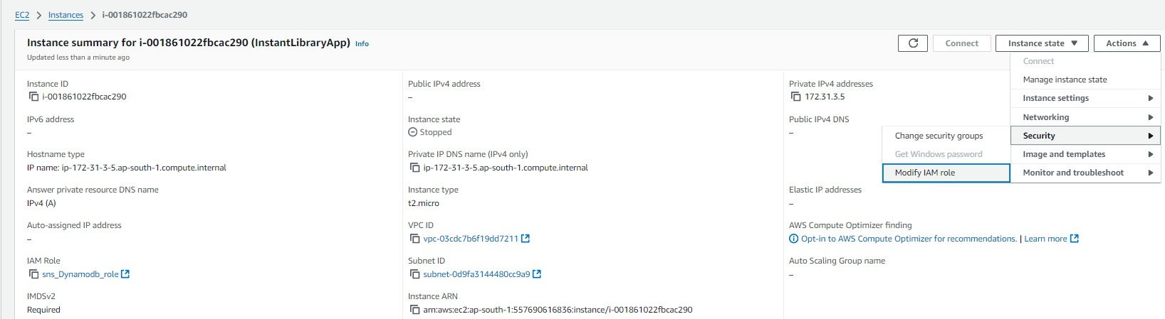

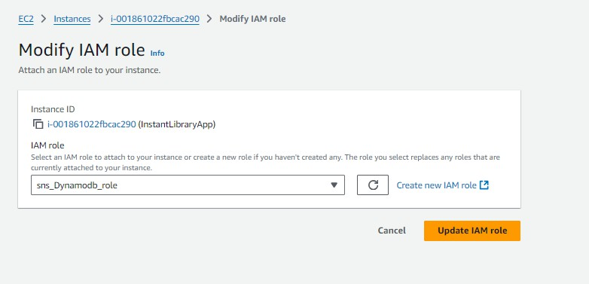

* Now connect the EC2 with the files

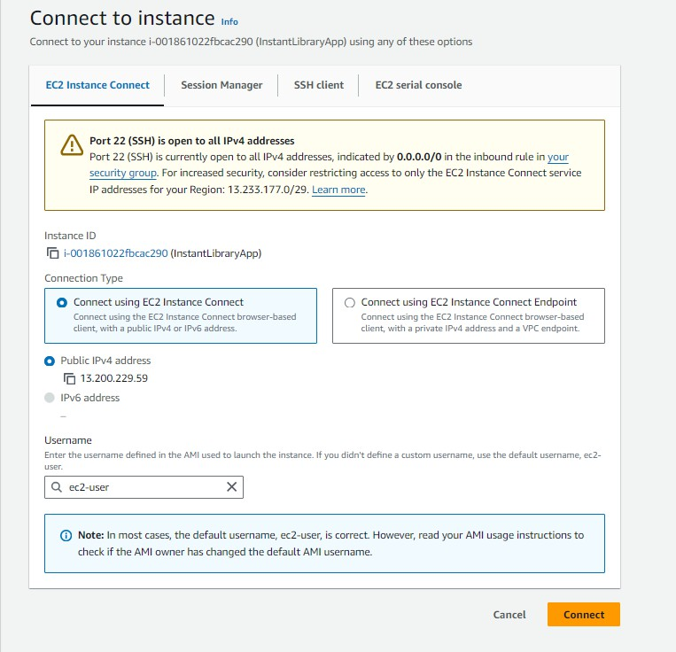

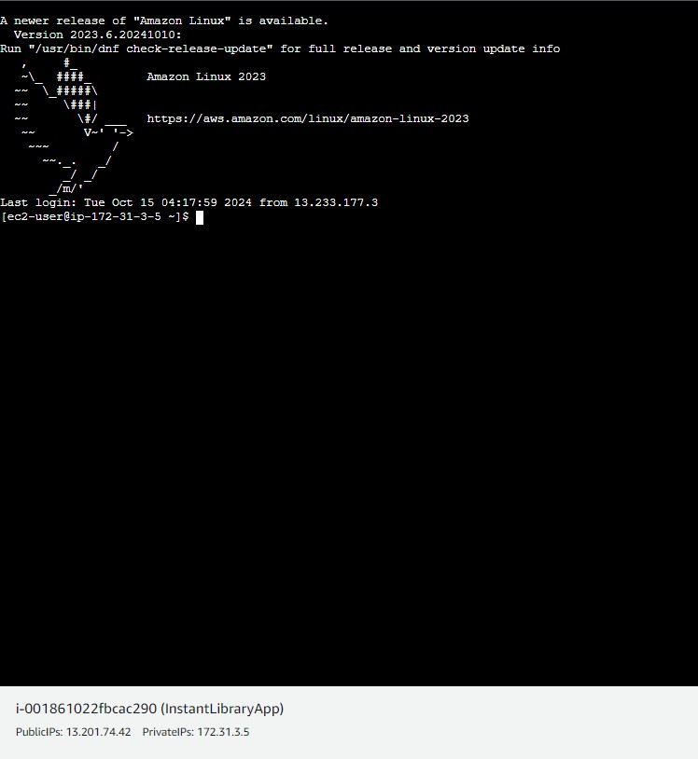

**Milestone 7: Deployment on EC2**

### Activity 7.1: Install Software on the EC2 Instance

Install Python3, Flask, and Git: On Amazon Linux 2:

sudo yum update -y

sudo yum install python3 git sudo pip3 install flask boto3

Verify Installations:

flask --version git --version

### Activity 7.2:Clone Your Flask Project from GitHub

**Clone your project repository from GitHub into the EC2 instance using Git.**

Run: ‘git clone <https://github.com/your-github-username/your-repository-name.git>’

Note: change your-github-username and your-repository-name with your credentials here: ‘https://github.com/dokihasritha-1418/medtrack.git

This will download your project to the EC2 instance.

### To navigate to the project directory, run the following command:

cd medtrack

### Once inside the project directory, configure and run the Flask application by executing the following command with elevated privileges:

**Run the Flask Application**

sudo flask run --host=0.0.0.0 --port=80

**Verify the Flask app is running**: [http://your-ec2-public-ip](http://your-ec2-public-ip/)

* Run the Flask app on the EC2 instance

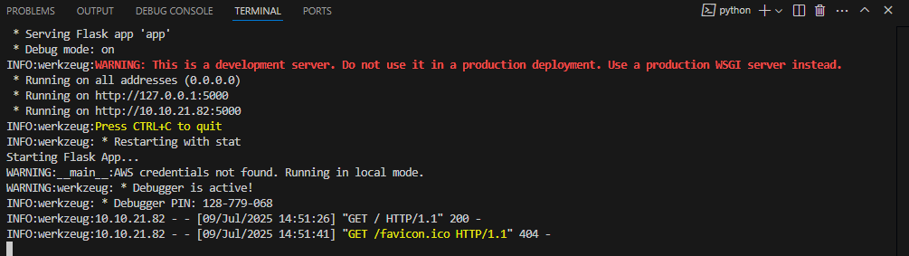

### Access the website through:

**PublicIPs:** http:// 3.93.51.138:5000/

## Milestone 8: Testing and Deployment

### Activity 8.1: Conduct functional testing to verify user registration, login, book requests, and notifications.

**Login Page:**

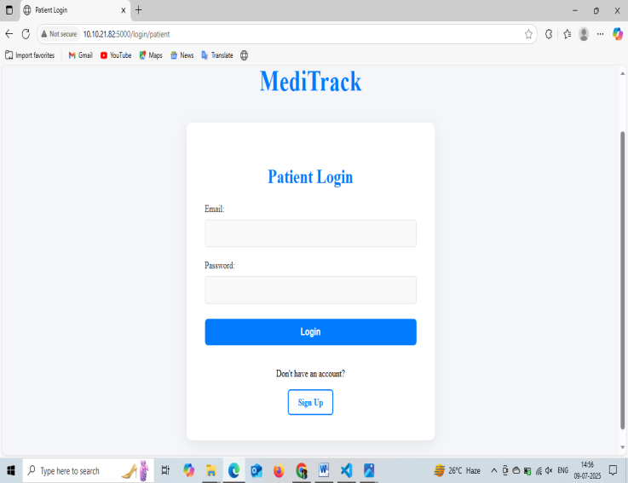 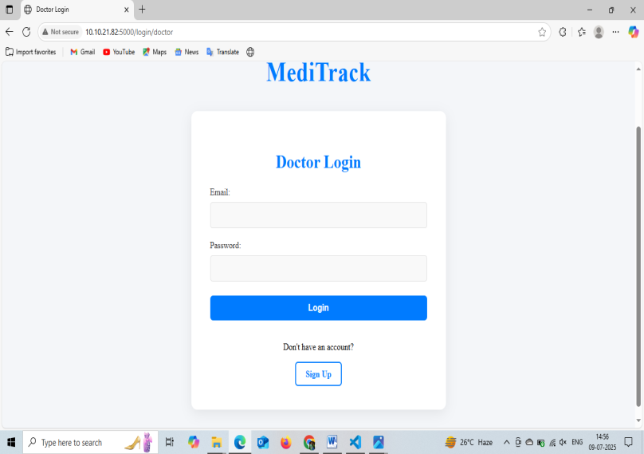

**Register Page:**

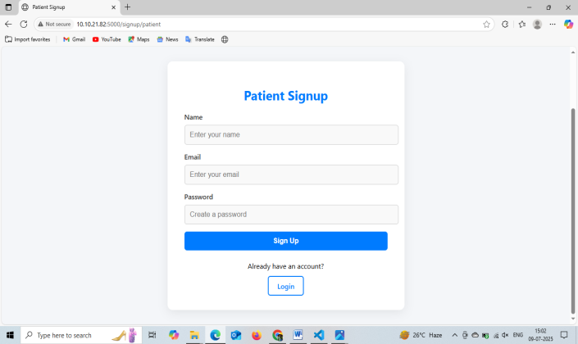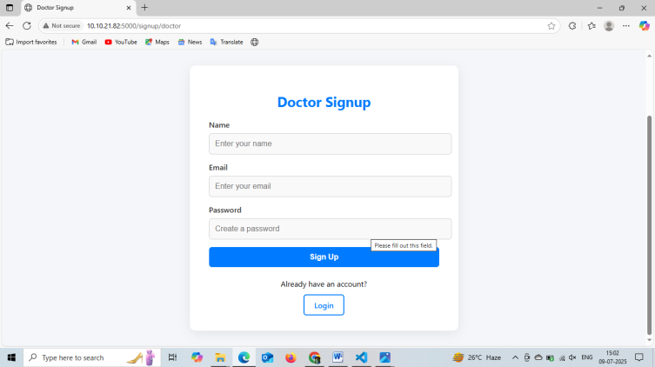

**Home page:**

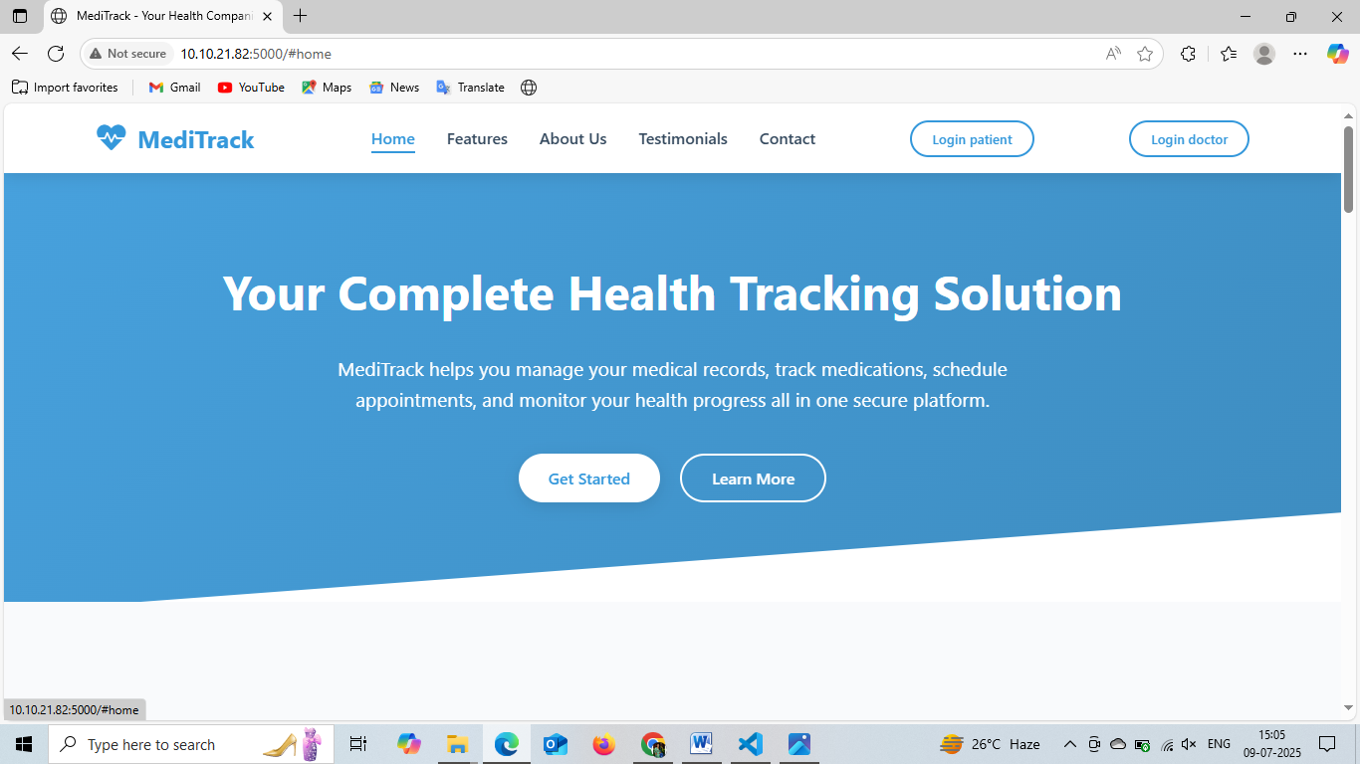

**About Us page:**

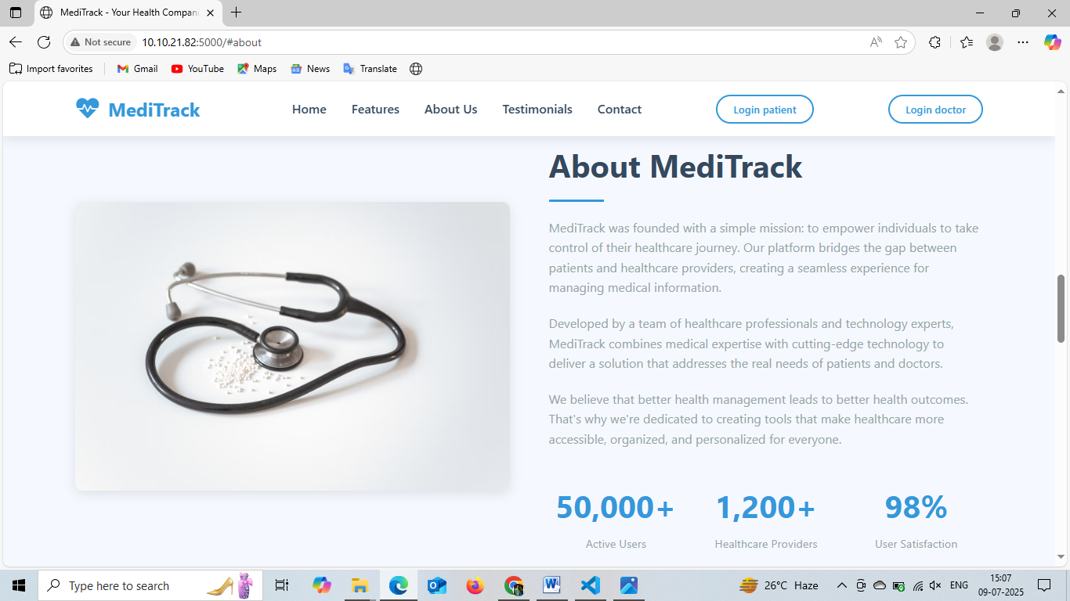

**Contact Page:**

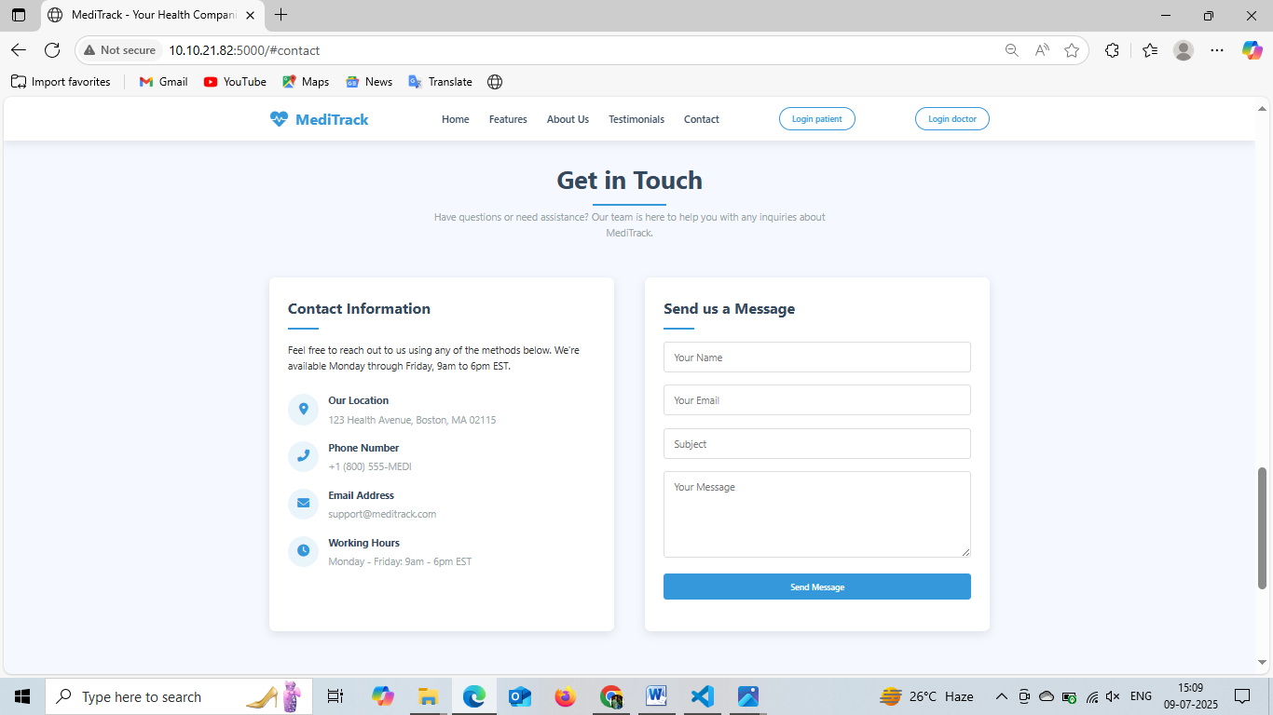

**Features:**

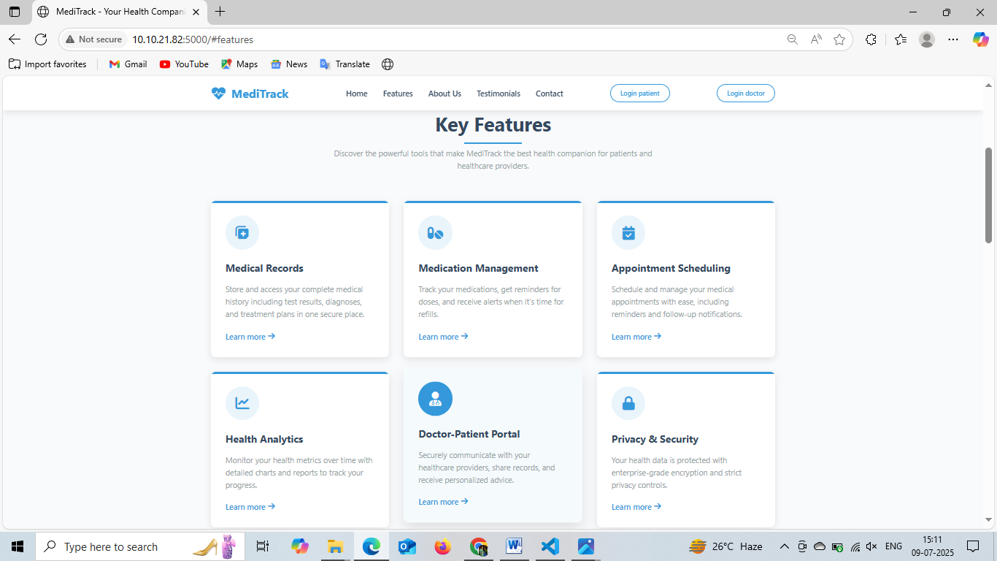

**Testimonials:**

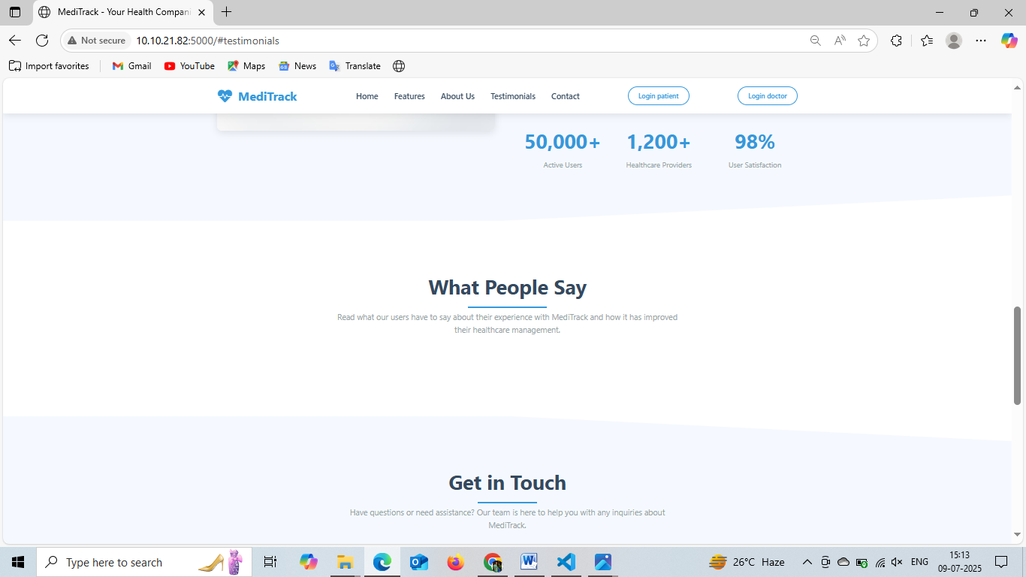

**Patient Dashboard:**

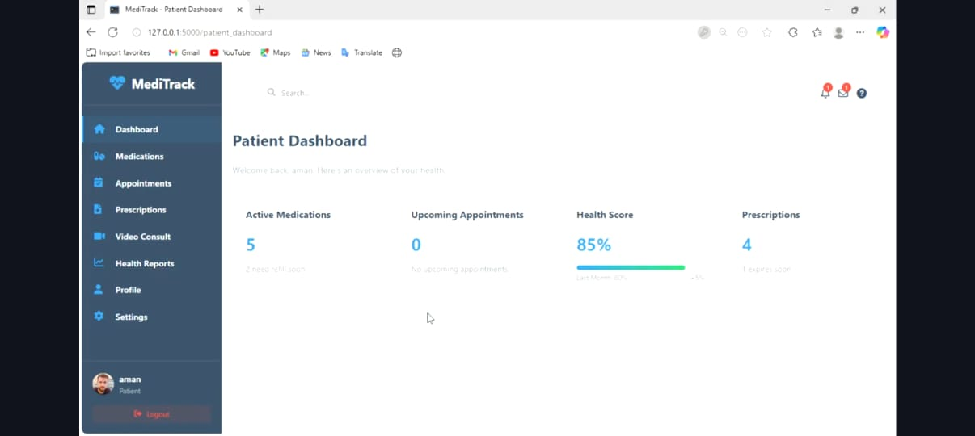

**Schedule Appointment:**

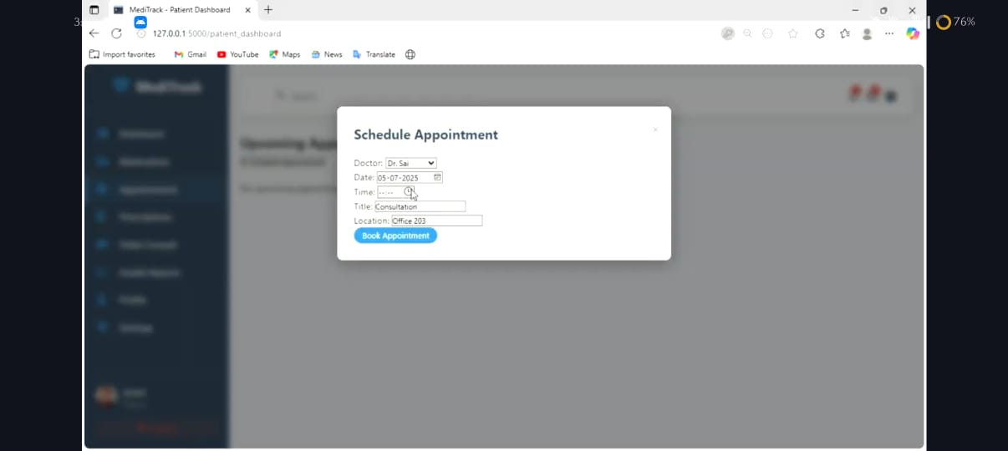

**Doctor Dashboard:**

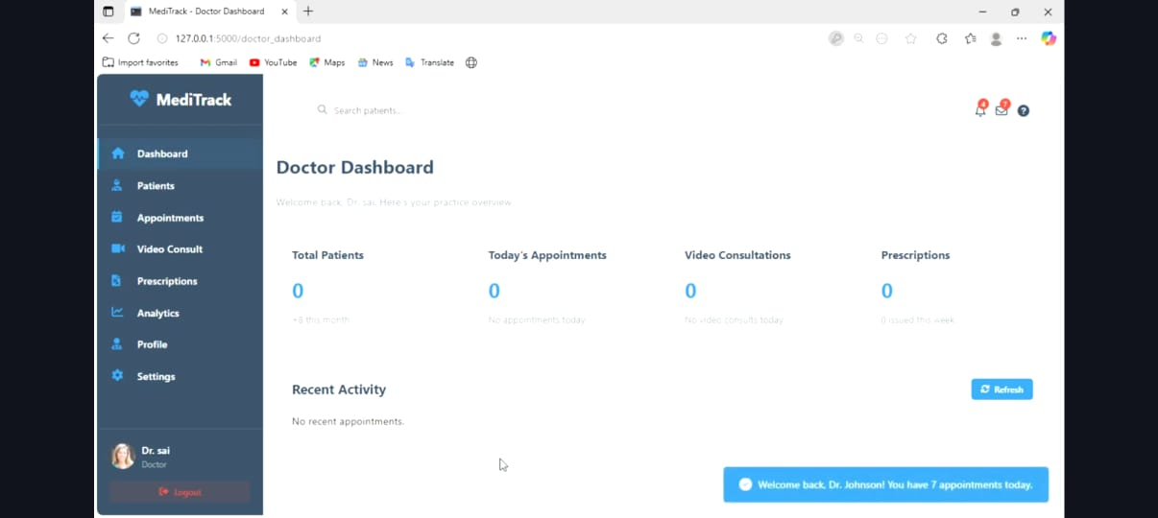

**Create Prescription:**

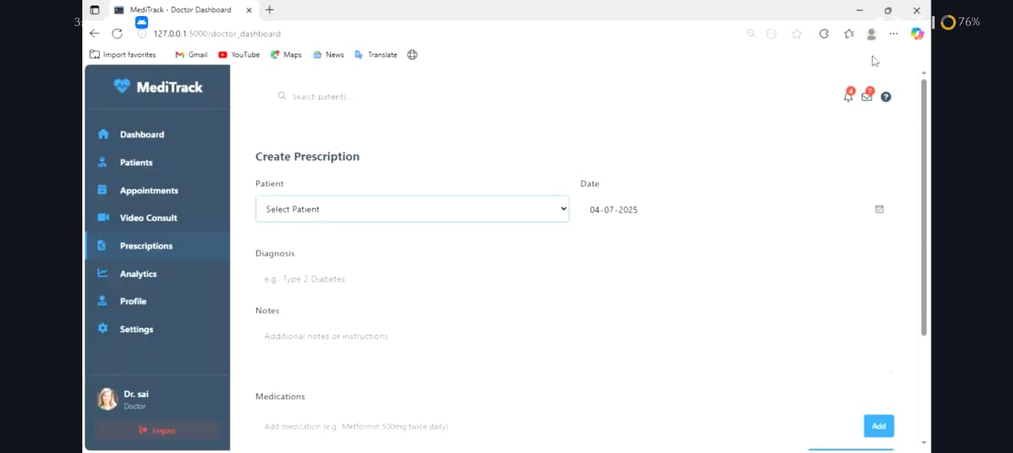

**Exit:**



# Conclusion:

The **MedTrack application** has been successfully developed and deployed using a robust cloud-based architecture tailored for modern healthcare environments. Leveraging AWS services such as EC2 for hosting, DynamoDB for secure and scalable patient data management, and SNS for real-time alerts, the platform ensures reliable and efficient access to essential medical tracking services. This system addresses critical challenges in healthcare such as managing patient records, monitoring medication schedules, and ensuring timely communication between healthcare providers and patients.

The cloud-native approach enables seamless scalability, allowing MedTrack to support increasing numbers of users and data without compromising performance or reliability. The integration of Flask with AWS ensures smooth backend operations, including patient registration, medication reminders, and health updates. Thorough testing has validated that all features—from user onboarding to alert notifications—function reliably and securely.

In conclusion, the MedTrack application delivers a smart, efficient solution for modernizing healthcare management, improving patient care, and streamlining communication between medical staff and patients. This project highlights the transformative power of cloud-based technologies in solving real-world challenges in the healthcare sector.

.